It is as if you were growing stuff

Pippin Barr x Devolution

Abstract

@ A MAZE. / Berlin 2025

# readme.md

* Read the **Dialogue** (Chapter 1) between Pippin and Csongor for high-level reflections on the design process and the general concept of the exhibition,
* **Booklets** (Chapter 2) for their ideas on this booklet series, and
* **On-Stage** (Chapter 3) for their struggle to come up with the
* accompanying **Program?** (Chapter 4) for the event.
* Read **The Dessauer Press** (Chapter 5) for discussions and reflections on the editing process of these booklets.
* Take a look at the evolution of the **Miro boards** (Chapter 6) to see how the team structured their work,
* **Timelines** (Chapter 7) for the ideation process of the timeline of the series, and
* **Titles** (Chapter 8) for the difficult ideation how the exhibition should be called.
* Check **Exhibitions** (Chapter 9) for some early mockups of the exhibition.
* Read **Versions** (Chapter 10) for design reflections and ideas on how to exhibit several versions on one screen.
* Read the **Commit History** (Chapter 11) for detailed, moment-to-moment insights into the whole development process.
* Look at the **File Structure** (Chapter 12) for the evolution of the project structure.

## A note on the text

This is the *catalogue / curators statement / meta-booklet / process documentation* of the exhibition *Pippin Barr x Devolution: It is as if you were…* at *A MAZE. / Berlin 2025*.

The booklet is based on the repository of the project. As a physical artefact it preserves the state of the project in a certain moment in time, when still far away from being finished. Please visit the repository[1] to see the full (?) design journey and reflections.

The text has been edited for print, but remains as close to the original as possible. Its main purpose is to provide the original material for exploration, the data is preserved *as is* and not updated.

The repository is only a small part of a larger project and does not adequately or equally represent everyone on the team. Please check the full credits for their amazing contributions[2].  
Without you, this would be nothing! ❤️

## It is as if you were…

*It is as if you were…* is an ongoing series of experimental games by Pippin Barr:

🌱 It is as if you were/  
├── ♟️ playing chess (2016)/  
├── 🖥️ doing work (2017)/  
├── ❤️ making love (2018)/  
├── 📋 doing paperwork (2022)/  
├── ⌨️ playing a text adventure (2024-)/  
├── 📱 on your phone (2025)/  
└── 🌸

In order to understand the development process of the series, it is important it in the context of a few other events in Pippin Barr’s life/career:

* joining the project *Speculative Play*[3] in 2017
* co-publishing the *Games as Research*[4] website in 2018
* co-publishing a paper about the development process of *It is as if you were doing work* and the idea of MDM[5] in 2018

100% a series yes! There are some bits in there where I feel like they end up being a bit about distinct things. I think of *Love* and *Work* as both existing in specific fictional universes where they’re “needed” as a kind of therapeutic intervention into a problem. *Chess* didn’t really come from that place, was more of a “wouldn’t it be funny if…”. And then *Phone* is unclear to me right now… I think probably giving it some Speculative Play scaffolding does make a bit of sense, but it feels reactive to exactly *now* rather than the future? So I’m not even sure it works out as speculative at all…[6]

I first tried documenting this history in anxious blog entries […]. Later, I turned to writing lengthy design reflections in private Evernote journals. These days, the process has become much more sophisticated, and it even has a name. I work with what my colleagues and I call MDM, or the Method for Design Materialization[7] .[8]

## The Stuff Devolutions Are Made Of

*Devolution*[9] is an ongoing artistic and/or design research project aimed at understanding and dissecting the process of game development, encountering new characteristics and features with each new iteration. Historically, *Devolution* began as an exhibition of the development process of selected games.

The core of each exhibition is a visual timeline of around 6 to 8 playable versions of a game, often including prototypes, in-between or afterrelease states, and dead branches, accompanied by contextual information, developer tours, talks, and discussions. Visitors can explore the timeline and development histories of the games by comparing versions to each other and find interesting aspects on their own.

For the player… well I continue to like the idea that the game itself (and this series and many of my things) are a kind of vehicle for research by the player at a more controlled level. You play this game and you are, yourself, investigating the nature of shadows in Unity, encouraged to think about and focus on them.[10]

Rather, most of the design work takes place in conversation with stuff. […] When you’re listening, the stuff games are made of is not quiet, not transparent, and not just there to be used. It’s a close companion, offering up its own ideas about game design all along the way.[11]

If the stuff isn’t going to shout, we’ll have to lean in. To make the results accessible, we’ll need ways to explicitly document such design work. It has long been a goal of mine to present a completed video game together with the design history of how it came to be.[12]

# dialogue.md

## 2025-01-08 Csongor

Hey Pippin,  
I guess we need to *start it somewhere,*  
*so le’s start it*[13] here.

Voice would also have been an option, [GAMETHING](https://gamething.life/)-like, but sorry, this somehow feels more natural to me. Also maybe I’m not confident enough with my spoken English, maybe even my voice. Whatever, we can aim for either/or/both in the long run, let’s see where this all gets us.

I’m incredibly happy to have the opportunity to explore and exhibit the development process of one (?) of your games, as you also explore and exhibit the development process of (your) games. In this sense, your work has always been important for Devolution (sorry I got used the use this term for everything related to understanding the development process, but I mean it in a very broad sense), has been crucial in helping us along the way with ideas and inspiration. [Games as Research](https://www.gamesasresearch.com/), [The Stuff Games Are Made Of](https://mitpress.mit.edu/9780262546119/the-stuff-games-are-made-of/), obviously.

I’m a bit afraid of too much meta-ness, thinking about thinking, exploring explorations, exhibiting exhibitions… but I think we can manage, I just felt I had to mention it once.

Sorry to start so early with some organisational questions, but we only have 4 months for all this.

Should we focus on the exhibition/ exploration of one of your already finished (whatever that means) games? Which one (well known, last, well preserved/ documented?)?  
Do you maybe have something that is not already on [GitHub](https://github.com/pippinbarr?tab=repositories)?  
Or do we want to showcase one of your ongoing research/ development processes? Are you currently working on something that could be included here? Will you still be working on it during [A MAZE. / Berlin 2025](https://2025.amaze-berlin.de/)? Show how you work, think, search directly in the exhibition, live.  
Or any other ideas?

Looking forward to all this! Looking forward to whatever you think!

## 2025-01-08 Pippin

Saw the invitation to this repo in the morning and immediately though *what a good idea*. I love it. Text is more my thing than anything as well - maybe I’m suspicious of my voice too… almost seems like a glamorous paranoia.

Just about to have to make lunch and then devote some time to projects so this is the right moment to quickly get back to you I think.

In short, I think any of the paths you mention can work, but I definitely have this ongoing desire to have it be an *in progress* project in the sense that it might be possible that I could still be working on it when A MAZE rolls around (though frankly ideally not). But even just having worked on a project *with this exhibition in mind* is funny and meta.

So yeah, I just started a project I’m calling *It is as if you were on your phone* which is another installment of my series of speculative future applications along with *It is as if you were playing chess*, *It is as if you were doing work*, and *It is as if you were making love*. This one kind of returns to the chess idea but in a much more generalized sense: it’s a simulator of being on your phone. Swiping, tapping, frowing, smirking, mostly being deadfaced. I have this idea (in the docs) that it’s this repeated turnaround… the app exists as a kind of cover when you’re in public: you look like a nice normal person on their phone. But it’s actually a meditative aid, because you’re *not* on your phone, you just performing the (soothing?) ritualistic gestures. But actually you *are* on your phone in the end, because… you’re on your phone.

I won’t go into depth because that’s what the game’s repo is for, but it might be a fun one. There’s a chance it’ll be an extended project, too, because I want to make its fraternal twin *It is as if you were on your computer* to go along with it, with the same framework but different base interactions and presumed context. Kind of an “anti boss hotkey” in way?

Anyway it would be my institive preference, but it’s subject to a couple of concerns:

* What if I burn out or bore out and don’t finish?
* What if it’s not very good? (I mean, I’m going to try but who can say this early on)
* What if it’s really frustrating for you and us to work on exhibiting something that’s perpetually in some kind of flux in realtime?

What do you reckon? I finished *Let’s Snake: Ancient Greek Punishment* recently, which is quite well documented, self-contained, fairly amusing…?

## 2025-01-09 Csongor

What a start, thanks for the faaaaaast answer!  
But also: noooooooo! I need to run to a conference, more time please.  
I have so many things I would like to say.

## 2025-01-10 Csongor: Sorting thoughts

Trying to incorporate answering into my routine, it is not really working…

I have always felt that for Devolution, working with *finished* (and already proven *successful*) processes is cheating. Are games ever finished? Are open processes always successful? I would love to see the “flux in realtime”! I want to see the dying branches!

But I also don’t want to pressure you. Do whatever you want, Devolution should not affect the development of your game (at least not in this sense).  
Or is it already? I have some starting *uncertainty principle/ observer effect* vibes.

What if we exhibit/ explore an ongoing process?

What if we focus not on the development of *It is as if you were on your phone* alone, but on the *It is as if…* series as a whole? This would take some of the pressure off you, ease your stress about having to *deliver*… and we could already start some initial preparations on our end (more in-depth research, initial ideas to structur the process).

I have tried to get a first overview of *It is as if…* as if it were one thing, and have already seen a lot of interesting things happening (improvements/ variations in the journaling, more and less living branches, development of the *Games as Research* ideas in parallel, shifting focus):

* [*It is as if you were playing chess*](https://github.com/pippinbarr/it-is-as-if-you-were-playing-chess) (2016)
* [*It is as if you were doing work*](https://github.com/pippinbarr/itisasifyouweredoingwork) (2017)
* [*It is as if you were making love*](https://github.com/pippinbarr/itisasifyouweremakinglove) (2018)
* [*It is as if you were doing paperwork*](https://github.com/pippinbarr/it-is-as-if-you-were-doing-paperwork) (2022)
* [*It is as if you were playing a text adventure*](https://github.com/pippinbarr/it-is-as-if-you-were-playing-a-text-adventure) (2024-)
* [*It is as if you were on your phone*](https://github.com/pippinbarr/it-is-as-if-you-were-on-your-phone) (the plan)
* *It is as if you were on your computer* (the distant plan)

Do you see this all as being one?  
Is it too much for a small exhibition?

And we can also just postpone the final decision to a few weeks later… but in that case we need a backup plan. [*Let’s Snake: Ancient Greek Punishment*](https://github.com/pippinbarr/lets-snake-ancient-greek-punishment) sounds great. I feel [*v r 5*](https://github.com/pippinbarr/v-r-5) or [*v r $4.99*](https://github.com/pippinbarr/v-r-4-99) could also work well, especially in an exhibition. That would add another meta layer, but less allow for the idea of live work.

For the player… well I continue to like the idea that the game itself (and this series and many of my things) are a kind of vehicle for research by the player at a more controlled level. You play this game and you are, yourself, investigating the nature of shadows in Unity, encouraged to think about and focus on them.[14]

## 2025-01-10 Pippin

No rush no rush! Did a tiny bit of prototyping on the phone game yesterday so it’s creeping along. Have started puzzling about it having many different forms and specializations, a whole app ecosystem of different apps for pretending you’re doing different things. Rilla (my wife) asked when I was going to make *It is as if you were being a person* which… well in a way the phone game it that, but it did get me thinking about a podcast/album of tracks that offer you in-ear instructions on how to be a person in different contexts. Could make one for A MAZE.

## 2025-01-10 Csongor: Parallel thinking

This all sounds like a potential awesome match. I feel more and more *It is as if…* it is.  
It is as if we would exhibit/ examine an ongoing process.

## 2025-01-13 Pippin: Great minds

Huh, yes I think the idea of a kind of more general *Is is as if* thing could work really well? Gives us plenty of material to work from with the earlier games (including paperwork! ha!). And then also does happen to be the thing I’m devoting my cycles to right now in terms of *It is as if you were on your phone* (did more today), but branching out both into the idea of an “app ecosystem” suite of *It is as if*s for social camouflage (or meditation?? A point of tension for me right now; maybe that should be a “mode”?); and into the idea of *It is as if you were being a person* as a funny “end game” of all this.

So yeah this has legs? “Worst” case we can bomb out into previous work like *Work* and *Love* and *Chess* which have plenty of documentation already alongside the “failed” version of the one I’m doing know. And I can sit in the exhibition space sobbing about my failed project!

Best case it’ll be even more complicated!?

## 2025-01-20 Csongor: Serial

(I have to stop talking about this all the time, but) how does time pass so fast, hasn’t 2025 just started a few days ago? Anyway, we finished [devolution.online/lmd](https://devolution.online/lmd/), really proud of it. Can / should we aim for online elements in your games? I would love to, although it would again be a first, as your processes are already living online, how can we add to them?

It is inspiring to see you *working*[15] and *reflecting*[16] next to us… don’t feel watched! What does this do to us? I for sure feel strange observing you from a distance.

Give us some time to get an overview of *It is as if…* before we move on to some follow-up questions and possible ideas for working with the processes in the exhibition. How much do you want to be involved in all this? Not only in the development of the game, but also in the exhibition/exploration of the process? Oh, but you already do that… I mean the additional layers? This meta-ness is causing me some troubles. I realise that this time our task is to make things, decisions, reflections *more* visible.

I also have an easier question:  
Do you have by any chance ANY other material about any of the *It is as if…* games that you don’t have in your repositories (or in your book?)? I can imagine the answer, but I have to ask…

Do you consider the *It is as if…* games to be a series at all, all coming from the same core? On your website you use the tag **Speculative Play** only for *Work* and *Love* and now *Phone*, but not for the others. Not even for *Chess*, which was a first. Are they for you outside? And what happened to *Adventure*?

Or are they more twins, coming in twos? *Work* & *Love*. *Phone* & *Computer*.

Oh, I have just found this in *The Stuff Games Are Made Of* (p. 61), when you write about *Work*:

I had decided to call the game *It is as if you were doing work* to bring it under the umbrella of a series of games I was making in which players *pretended* to be doing something on their computer or cellphone rather than “really” doing it. By then, I’d already released *It is as if you were playing chess*, in which you make the gestures and facial expres- sions of a chess player according to instructions on the screen.

So it’s a series! So has *Phone* and *Desktop* always lured behind *Work*? And what should *Love* think about that?

## 2025-01-24 Csongor: Devolutionizer

I once wanted to design a chat interface that also visualised the duration of writing. When did it start, how many keystrokes were made, how much was deleted? These overlaps in chats are so interesting, but the interfaces are not able to work with them in a meaningful way.

Anyway, here I am, writing to you, perhaps in parallel.  
I’m thinking about all this because I’m still asking myself how much you want to be involved in our exhibition considerations. Surprising the developers has always been a big part of the beauty of Devolution exhibitions for me, we are taking that away with this. Let me know if this feels like too much, too much detail… and if so, ignore the rest of this message.

And we can move to a more abstract level and talk about research and growth and metaphors.

We don’t have sooooooo much space, only for about 4 - 6 screens, with tablets/ phones maybe a bit more. We need to evaluate this further, but that is the tendency. Thinking in *As if* dimensions, that’s generally one screen per work.

But how to keep the idea of the timeline more? How to keep the parallelism of versions, as a space to explore, to compare?

I had an idea. Or was it a dream?  
Your *As if* games are the first games we deal with that do not need to be built, but can be played directly from the *raw* data of the repository. This means that we can just easily build something that will check out all (a few selected?) versions of the game, visualise them in some kind of sidebar/ header, so that they can be easily played from there.  
The more I think about it, the more I like it. I know of all the repository analysers and visualisers, but not something like this.  
Ok, yes, you can do it with any git client and an open browser, I know. But I mean a more curated version.  
Will have to let that sink in.

Talking like this feels like *using* your games. I hope you are really ok with all this…

## 2025-01-31 Csongor: Games made of OOP

Oooh, I can’t not jump on this:  
[I OOPed in the code pool; I wanna be an FSM (2025-01-28)](https://github.com/pippinbarr/it-is-as-if-you-were-on-your-phone/blob/main/process/journal.md#i-ooped-in-the-code-pool-i-wanna-be-an-fsm-2025-01-28)[17]

I have always felt that the stuff that games are made of is OOP (ok, and as such also data-driven-ness). That it is the structure of the objects that leads the way (how games grow). Objects finding their right place over time, connecting with others, with their environment, eating/ encapsulating each other, morphing. I always wanted to follow up on this, almost in a [Platform Studies](http://platformstudies.com/) kind of way. Or in a *The Stuff Games Are Made Of* kind of way? Is OOP some kind of a natural habitat for (digital) games? Can you go against it?

Did you know that if you search for OOP in your book, all you find are loops?

## 2025-02-01 Csongor: Letterpress

Things are sinking in. I like this phase of understanding more and more, of getting a feeling for the material (what do we have, what are the possibilities), things more and more connecting to each other, slowly building a whole, slowly taking shape. It’s almost too fast, need to slow down.

Can we turn your process documentations into booklets?  
Not sure about the extent, we are still reading ourselves into your processes, but some kind of a nicely layouted and designed accompanying material to the versions of the games. Journals, manifestos, the changing todos, maybe extracts from other sources, your texts, other texts. With the booklet for *It is as if you were on your phone* half finished, with blank pages at the end that we can fill as you work on it…

The commit message booklets were always something visitors have enjoyed a lot. This would be a great next step. Opens up nice possibilities for exploration, reading next to checking the versions, comparing, discovering.

And also things like: a limited edition (to sell?). We have a really nice printing lab at the university, letterpress, offset, flexo, etc. We could do some nice looking covers for all of them, a bundle.

## 2025-02-13 Pippin: 😬

Oh no! We’ve run into a classic technical hiccup where I wasn’t receiving notifications from GitHub telling me this project was being updated with commits. I was just floating around in sweet oblivion like usual.

Although in that time, as you saw, I was putting some pretty decent work into *It is as if you were on your phone* (and have done more stuff this week too). Last week I was in Albuquerque giving a talk at the [ARTSLab](https://film.unm.edu/facilities/artslab/) at the University of New Mexico which included some reflections on the *It is as if* series and ended up with a little bit about *Phone* and even *Person*. So at the very least there’s, like, progress happening.

There’s a ton of stuff to follow up on here so let me at least try to get to some of it and we keep chatting…

Can / should we aim for online elements in your games? I would love to, although it would again be a first, as your processes are already living online, how can we add to them?

It was really exciting to return to the latest Devolution project. Funny that they start at the top of the mountain and head down - obviously because of the way the game works, but it’s such a fun inversion of the idea of the hardship of climbing the mountain and reaching the pinnacle. Pretty provocative idea that game dev is like kind of coasting downhill… though of course you can go too fast and crash and… well, it’s a generative metaphor.

I don’t see why we couldn’t do some stuff, though yeah not 100% what that might look like. Maybe it’s two separate projects?

How much do you want to be involved in all this?

Haha. I *feel* very involved and am happy to be! Things are pretty intense at work at the moment (being department chair is something I’m more and more used to, but it doesn’t quite shift the amount of work it is). I mostly assume I would heavily defer to you on anything exhibition related though - I don’t think it’s my area, I mostly have it in mind to be as helpful as possible?

Do you have by any chance ANY other material

Hmmm, I *think* the answer is probably no, but I could be wrong! I mostly tried hard to get all my notebook materials and so on while working on games. I could try to track down my notebooks from around that time, but I’ve increasingly moved to all digital for design stuff - maybe for the worse?

So it’s a series! So has *Phone* and *Desktop* always lured behind *Work*? And what should *Love* think about that?

100% a series yes! There are some bits in there where I feel like they end up being a bit about distinct things. I think of *Love* and *Work* as both existing in specific fictional universes where they’re “needed” as a kind of therapeutic intervention into a problem. *Chess* didn’t really come from that place, was more of a “wouldn’t it be funny if…”. And then *Phone* is unclear to me right now… I think probably giving it some Speculative Play scaffolding does make a bit of sense, but it feels reactive to exactly *now* rather than the future? So I’m not even sure it works out as speculative at all…

I had an idea. Or was it a dream?

I think this thinking around being able to (somehow, technical stuff la la) view/slide between different prototypes/versions makes a lot of sense. I suspect they should be curated rather than letting people encounter absolutely any commit, but that seems pretty doable to me… I can imagine at worst a series of cherry-picked commits displayed and you click them and end up playing the game at that state. Conceivably even have the commits visible at the same time if the monitor is big enough etc.

Is OOP some kind of a natural habitat for (digital) games? Can you go against it?

Yeah this is such an area of interest for me! I have a dream of writing a book/something where it’s all about making connections between fundamental elements of programming (loops, variables, OOP, and more) and the ways that videogames work (and don’t work?). Kind of like obsessively documenting the “grain” of programming in the context of game design or something? I think it’s clear there’s something there.

Can we turn your process documentations into booklets?

I kind of love this personally. I’ve been more and more into making little zines just lately so little books are super appealing to me, and there’s that funny way they leverage a kind of “seriousness” that something glowing on a screen doesn’t have. Would love to explore.

I one was in discussions with a gallerist about trying to produce a limited edition of *The Artist Is Present* as a set of books one listing source code, one with all the assets, etc. Kind of over-the-top “luxury” or something, and also *sort of useless* compared to a repository, but funny to imagine reconsituting a game from books (harks back to the “typing in BASIC programs from a magazine” days - not that I lived through those days).

So yes let’s explore? Feels like a nice direction to me. My work is ultimately so driven by *writing* that “books” makes a lot of sense to me.

And merch. I’m so into the idea of “merch” these says. I wear this sweatshirt from Lilith Zone’s online store, it’s got a texture of *Crypt Underworld* on it. I aspire to have such a great thing emerge from one of my games (my wife Rilla’s been designing a t-shirt based on *It is as if you were doing Paperwork*). I connect merch strongly with bands and how much I wish being a game dev was more like being in a band?

## 2025-02-18 Pippin: 💪

Dropping by to say… well I’m making a bunch of progress in the Phone game which has felt good. Feel more and more like I understand its identity and it will clearly be ready before AMAZE which means I’ll hopefully be working on one of the next iterations like Computer or the Suite? There’s no shortage of games to plug away at between now and then so I’m confident there will be some cause for me to be The Designer Is Present-ing.

## 2025-02-24 - 03-03 Csongor: Open World

I need to get better at finishing messages. Started answering a while ago, but switched computers without committing. A classic, I suppose.

So many threads! Not sure how many we can keep going at the same time, lets see. We may need another structure soon…

it’s such a fun inversion of the idea of the hardship of climbing the mountain and reaching the pinnacle. Pretty provocative idea that game dev is like kind of coasting downhill… though of course you can go too fast and crash and…

I swear - and I almost don’t believe it myself - we never thought about this aspect of the metaphor! We use it in some visual jokes (the Kickstarter campaign, someone leaving the team) in this sense, but we have never consciously thought “going fast and crash”. I still/ constantly wonder how metaphors work. I mean, I know the theory, but reality is surprising.

Talking about metaphors:  
What do you think of *growth* & *gardening*? Does it make sense to you in general as a metaphor for the game development process, for observing, listening to what the game wants, for the game doing things on its own? Does it make sense for *your* own games? For the whole *It is as if* series… or for each individual game?

Is *Phone* growing?  
Based on its OOP and data-driven core… or are other forces stronger?

I’m using this metaphor for so long, I don’t really see it anymore. I generally still love the core of it, it works so well on so many levels to explain and explore the creative process of games. But there are a couple of aspects that have been bothering me more and more:  
On the one hand: a simple oversaturion. Not for me (or is it?), but *out there*. An oversaturation of nature and nature-related *everything*, in art and science, in books, bookstores, museums, politics, everywhere. Of course, all of this is inspired by what is happening around us, and rightly so. But it has influenced how people see the metaphor. Is there a hype cycle for metaphors (as an underlying structure for metaphorology)? I feel like people don’t want to hear about it anymore. In the beginning *Game Design as Gardening* was an aaah-it’s-interesting, now it’s a nooo-not-again. Or is it just me?  
On the other hand: does it really cover everything/ enough of what is so interesting in the development process? Certainly not. But what percentage? For a long time it was helpful, especially as a claim. But I also feel more and more that it is too limiting, it does not allow to inclue certain aspects.  
For some time I have been trying to include *research* in *gardening*, and to some extent it works. But what does it mean (for me? for my ego?) if they are simply parallel?

Anyway, I’m still endlessly fascinated by the fact that Alan Kay studied biology and was inspired by ideas from there in the early stages of OOP…

“books” makes a lot of sense to me.

a set of books one listing source code, one with all the assets, etc.

Yesss, let’s just do the booklets!  
My initial feeling was to mainly include your journals, but… yeah, I think it’s a good idea to include more, source code, assets, visualisations, etc. I think I need to think again.  
I am strongly leaning towards a collage (rather than writing a lot of additional text), structured along the timeline. Not sure if it can work though…  
We’ll try to make a suggestion about the number of booklets and the content and layout… maybe here in the repository? Yes, I think so. We also need to find a good format, give us a few days.

My work is ultimately so driven by *writing*

Am I right in saying that you have never used so much visuals as in *Phone*? How did that happen?

One thing I always asked myself about MDM was: why so much text? Or perhaps: why this tendency towards text? I get it, the repository structure tends towards it… but don’t games tend towards [visualisations] (https://www.stonetronix.com/gdc-2010/)? Or are these two ends of the iteration loop: visuals for design, text for reflection?

I taught a course called *Drawing Ideas* a few years ago with a friend, colleague and comic artist [Sebastian Stamm] (http://www.the-stamm.com/wordpress/), basically as a documentation course for game designers. It was a great learning experience for both of us… I’ll have to check my notes!

well I’m making a bunch of progress in the Phone game which has felt good. Feel more and more like I understand its identity and it will clearly be ready before AMAZE which means I’ll hopefully be working on one of the next iterations like Computer or the Suite?

Congratulations! Sounds amazing… I’m really impressed by your efficiency (how do you do it?)!  
We will adjust our plans accordingly. I think what would be good to know is the form of the new project. Will it be a repository with a journal again? Or if it is *Person*, what will the format be?  
But don’t get stressed here, we still have some time to define…

This message is already long, and I still have other topics on my mind. Will make a list of them to not forget:

* logo / title / subtitle
  + some kind of a mix, a crossover?
  + should we go with the band? or letterpress style?
  + *Pippin Barr x Devolution*
  + *The stuff games are made of x How to grow a game*
  + *How to grow stuff*
  + *It is as if we would grow stuff?*
  + *It is as if we would exhibit/ explore the stuff games are made of*
  + *The Designer Is Present* is great for the live part!
  + I think we’ll come up with a few suggestions soon…
* presentation / talk
  + Devolution has appr. 1 hour of stage time
  + how can/ should we use it? presentation & intervewing each other?
  + any chance you see your talk you have mentioned above?
* what do we need to prepare for *The Designer Is Present*?

What an end. See you!

## 2025-03-05 Csongor: 🧵

Ok, I feel we need to spread out more, this one linear chat is not enough anymore.  
So in parallel with this message I’m also expanding the whole repository into a working one for the whole project, I hope that’s ok with you. Adding a lot of folders and files (structure?) for the future…

With so many markdown files I’m already confused about what is process and what is work, but that’s what we wanted (?) I suppose. Maybe we can keep this folder for more focused conversations and reflections (are these reflections?)… and the work happens in all the other folders?

I’m going to ask other team members to join… let me know if it gets too much and confusing.

See you in the other files! 🌱

## 2025-03-06 Pippin: 🤡

Oh my! Alright yes now we have a pretty significant file structure to work with. Which is good!

Other files for real work, this one for the ongoing conversational stuff. Works for me. I mean it’s technically what Discord is for I suppose (we could dump logs from there at some point though it’s less pure of heart in terms of commiting over time).

Trying to look over the questions in that last one to extract them and be accountable… ummmm…

What do you think of *growth* & *gardening*?

It’s a funny one for me because I’m not really a gardener in any sense but my wife Rilla is a very serious and talented gardener. So our house is full of thriving and beautiful plants, and our back garden is gorgeous, and the alley (ruelle) behind our house has also received her attention… but I on the other hand know little more than a bit of weeding-craft (which is probably relevant, but not very weighty).

So I like the metaphor but it doesn’t necessarily land with me emotionally? And in terms of the breadth of “metaphorical entailments” I think I have a pretty stunted (get it?) understanding of what it could mean/develop/reveal.

So I’m not sure if I think the games are growing, being attended to, cared for… it’s not the way I naturally think. I think it’s a reasonable metaphor but I don’t even know necessarily that someone else would see what I do and think of it in that way – do you? That’s an interesting question in general perhaps… is it one metaphor fits all or are there different metaphors that are more appropriate for different designers?

Am I right in saying that you have never used so much visuals as in *Phone*? How did that happen?

Huh! I wouldn’t have thought that even - do you mean in the sense of the visual prototyping stuff I’ve been including this time? It’s true I don’t normally do that but it seemed helpful for this project… I used to do a ton of sketching in notebooks back in the day, mostly around UI/screen layouts and how that can feed back into design decisions. The visual prototypes were kind of the same… this game was so incredibly simple that it’s really possible to understand almost all of it through a series of keynote-created images of pink circles and text hehe.

why so much text?

I think that’s a really relevant question, a big one. Answering for myself it’s not even really the repository thing - though it’s very true that text is what repos are tuned toward (especially if you think about diffs). I’m just an intensely words-oriented person, kind of always have been since I was small. And at some point (when? I don’t even know… hmmm…) I really started leaning into writing as a way to externalize and think through design processes; that kind of stream of consciousness that makes me ideally understand what it is I’m doing and allows me to question it.

I think that may be very specific to me and cruelly unnatural to some others who maybe spend more time creating images for example. On the other hand, it’s hard to get away from the written word being incredibly important if we’re going to talk about “research” at all… at some point we’re on the hook to *explain* what we’re doing and why we’re doing it and I struggle with arguments that those explanations can take non-textual forms… or at least that non-textual explanations are especially legible? It’s a big thing…

I love drawing, too, though, so I’m curious about your course - what happened in it? What does that output look like? Like I say, I often like to draw what a layout will look like to better understand spatial relationships especially, but I don’t naturally use drawings as a way to explain things… and really I suppose that in MDM it’s not really game design documentation in the design of a “design document” anyway, but more about exploring and explaining process (to yourself) which… maybe admits “less” of other visual approaches? But I feel like I’d be pretty happy to be wrong about that…

Maybe I need to make a game with no language and with no language in its process documentation either… just drawings…

I think what would be good to know is the form of the new project. Will it be a repository with a journal again?

Oh for sure. Anything I start up next wlil always be using MDM so it’ll always have the same shape. Even if it’s Person I’d work on it in a repo writing the scripts and prototyping audio and so on. I’m thinking too in the direction of making one of the Suite apps as well, and leaning into the meditation angle that I cut from the Phone game in the end.

Titles

Oh titles are so fun, I like basically all the ones you popped in there. Pippin Barr Devolved. I like the band style x thing.

Stage time

Whoa, stage time! Nice. Hmmm, I mean I think you and I in conversation about design process and making it visible is low hanging fruit… I worry we might bore people? It’s hard to talk about process documentation and get people excited??? Who knew???

I always want to have talking about work be funny… what do you find funny about this stuff?

That talk I gave recently is here: <https://www.youtube.com/watch?v=r1DTRdzrHXY&ab_channel=ARTSLabatUNM>

Designer is present

Hmmm, well the simplest version is just we have somewhere for me to sit and I sit there with my laptop (a powerpoint would be useful I guess). I thought the idea of an “ON AIR” sign would be pretty funny, but that’s just trimming. Could possibly project/show my screen somewhere, but I think it’s also fine if people just kind of looked over my shoulder.

I could wear a special hat. haha.

## 2025-03-09 - 16 Csongor: ☀️

Noooooo, I have been sick for a week. Sorry for the gap, I’m back again.  
Our next semester starts in a week, so there are a lot of things to do.

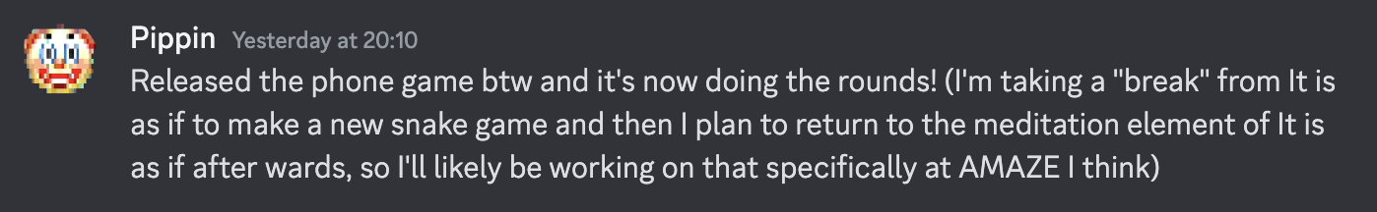

Discord message by Pippin about the release of Phone

Congratulations!📱  
“Doing rounds” sounds good, it is amazing to see the reactions out there, I hope you can enjoy them all!

I was already wondering why the zen element has disappeared…  
Sounds like a gooood plan for A MAZE. Should we nail it down? Can we do it at all?

it’s hard to get away from the written word being incredibly important if we’re going to talk about “research” at all… at some point we’re on the hook to *explain* what we’re doing and why we’re doing it and I struggle with arguments that those explanations can take non-textual forms… or at least that non-textual explanations are especially legible? It’s a big thing…

In any discussion about artistic a/o design research, the question arises if it is legitimate without an accompanying text/reflection. Can the work itself be / contain the reflection? I have always found these discussions interesting / inspiring, but also a never-ending loop. I often feel that it *should* be possible. But it is hard to argue, I *know* text is better.

Isn’t this just like teaching? How much do I have to *explain*? How does *insight* work? How much do I have to let someone *experience*? Find something on their own. How can I be sure they *got it*? Is there knowledge without knowing? Is this the opposite of *knowing that I don’t know*?

Oh, I just realised there is another parallel:  
Isn’t that also *how games communicate*? How much do they need to *tell* something as opposed to *trusting* in all the other dimensions.

Speaking of *trust*:  
Isn’t this also just insecurity? A kind of lack of trust in the work itself, that we have to explain in addition?

Devolution has always been, at its core, a *design research* project, with the idea of letting people explore the beauty / characteristics of the design process for themselves, to make their own connections. But of course: if that is the case, why am I writing texts about it?

In this sense, are your [v r](https://pippinbarr.com/ideas/v-r/) series also works like this, or are they not (see my quote from one of your journals above)? Do they need less explanation, less accompanying text?

But I feel I got distracted…

Maybe we need to sort more between *design* and *reflections* and *explanations*.  
For me it somehow helps to see it as two sides, design is more visual, reflection are more textual, and explanations are somehow on top. Does this make sense? If I consider design and reflections as an endless loop of iterations: its a mixture of both, seamlessly intervowen, small-scale alternating / complementing each other.

If we accept that games have a systemic / spacial core, it seems naturally to say, that one can better understand them with visual tools. The course *Drawing Ideas* was about this aspect, it has highlighted more the design side, the pre-thinking of a next step, less the analysis.

I have to admit that although we use and refer to MDM & Games as Research a lot in our game design department, we do it with one (big?) difference: we try to leave the form as open as possible (this also means that it does not *have to* happen in a repository). Even to the extent that we say: find your own (visual?) language, your own rhythm, your own style. In general, anything goes, but we specifically mention/allow Miro boards and [analogue notebooks](https://www.modulor.de/en/seawhite-sketching-pad-white-paper-140g-m2-210-x-148-mm-din-a5-tall-20-shts-40-pgs-st.html).  
It is great to see how students develop their own style, using visual and textual elements… but also influencing each other, or using external inspiration.  
Yes, I need to do more with this…

How did you make the first sketches for *Phone*? Tablet?

Looking more closely at your visualisations, I noticed that they are mostly pre-visualisations/variations of screens, never something that *thinks* about the inner workings. Do you never have the urge to visualise how something *works*?

I don’t think it’s about design documentation. Do you know the idea of the [One](https://www.stonetronix.com/gdc-2010/)[18] [Page](https://gdcvault.com/play/1012356/One-Page)[19] Designs by Stone Librande? I like a lot that at its core (it’s not so visible in the *original* presentation, but the idea has evolved a lot since its origin, see how Tracy Fullerton writes about it in - later issues of - Game Design Workshop) it’s about accompanying the process, thinking about the next steps, not describing the whole.

is it one metaphor fits all or are there different metaphors that are more appropriate for different designers?

Yes, I tend to forget how subjective metaphors are, so / also emotional.  
I think I still need to sort that out. Somehow I feel that there is another dimension hidden here, in the sense of: how did the metaphor inspire early computation and as such is interwoven into the materiality of games / digital structures. But whatever, feel free to ignore.

Ok, this message got longer.  
Because of my sickness, we also have a lot of other things to talk about, but I’ll leave that for later.

## 2025-03-28 Pippin: Limping along

Hey Csongor, geez… well that was a delay. I went to Rotterdam for a week in there, and then the return week at work has been a real doozy. In the meantime though I guess I’ve ended up delivering that artist talk/retrospective talk a couple more times which has been interesting. I don’t think it’s the right material for something on stage, but it’s been helpful for stirring up some thinking about what it is a bunch of my games/design is pointed at.

Can the work stand on its own?

Yeah this came up quite a lot in Rotterdam in fact. Conversations about artistic research and what constitutes research output. Whether “just art” can be thought of as a scholarly contribution etc. I think I’m a bit of a boring adherent to what’s maybe an old fashioned view that some sort of additional language is pretty much needed to understand what on earth is going on in most artworks. Though maybe videogames are different in terms both of their use of language internally and the ways in which they almost *have to* be quite legible and not oblique just in the nature of being designed experiences (though there are always exceptions).

If we accept that games have a systemic / spacial core, it seems naturally to say, that one can better understand them with visual tools.

This is a good an important one for design process stuff for sure. I think I might be a bit of an outlier in not relying heavily on visual stuff for my games. Quite often there are literally no sketches or mockups or anything… I think just because my ideas are so *small* (and often so primitive?) that they’re kind of easy to visualize entirely in my head, or if not that then directly in code.

But that’s not remotely true of other processes, where sketching etc. is vital to coming to grips with how things fit together. For the *Phone* game, I did end up doing various bits of “sketching” in Keynote, just in terms of thinking through different plausible layouts and ways of indicating the desired actions… symbols versus words, positioning, colour palettes, text styles, etc. And I do think that was helpful… I *could* have prototyped those in code, but doing it in Keynote was certainly faster for zeroing in on the main idea.

Visualizing how things *work* is really intriguing though. I mean, the answer is “no” on my end (I think?)… probably for similar reasons to the above… I’m rarely doing something so complex that it’s not more straightforward to just directly prototype in code/engine and find out how it works that way. Or it’s simply so incredibly simple that you can understand the system and design it without extensive diagramming etc. I’m struggling to think of a project that led me to do extensive pre-thinking about how things might work. Last night I gave (again) that artist’s talk about my work and one of the questions at the end was whether I had any insight into more systems-oriented/open ended forms of design. I kind of racked my brains and came up empty… I simply don’t practice that kind of design much… I feel like I’m trying to largely work on kind of deterministic work that’s more about it being open/interpretive at the thinking level possibly?

Brass tacks?

Not quoting you, just a header.

What do we really need to nail? I guess I’ll go into some other documents to see what I can uncover and ideally help out with?

## 2025-04-03: Csongor: Talking about drawings…

Hey, just a quick one, a task!  
Could you make a drawing, a visualisation of the whole *It is as if…* series? Somehow (branching?) visualising the evolution of the whole series, incl. *Chess* and *Work* and *Love* and *Paperwork* and *Text Adventure* and *Phone* and possible new games and iterations. You know, visualising ideas!

Aaaand yesss, let’s integrate your drawings…! But we need them in good quality. [Your Insta](https://www.instagram.com/pippinbarr/)[20] has a good amount, but it does not really allow us to download them and the quality is always restricted. Also, do you have more (maybe even design-related)?  
Would you mind uploading them here? But remember: what is in the repository stays in the repository. Who do I tell?!

See you!

## 2025-04-08 Csongor: Jump, jump!

Haha, I have just edited the /booklets/00_growingstuff/content/dialogue.qmd file first, a perfect glitch for this message!

Hey Pippin, something else, a big jump:

It looks more and more like it would make sense to put the versions we want to exhibit somewhere online (and not just locally). We are brainstorming ideas to let people play versions with scanning QR codes, etc. Not all of them, but some.

Aaand *this* repository would be a logical place for that. We would use the Player of the [Devolutionizer](https://github.com/csongorb/devolutionizer)[21] for this, it’s already in a nice shape, we’ll try to improve it even more. This all means that there would be some sort of hub / sidebar where people could select the versions they want to play.

We would give this repository a [BY-NC 4.0](https://creativecommons.org/licenses/by-nc/4.0/) license. I mean, hey, we already have your process documentations here (we use them in the booklets, we never really talked about it), and you have a BY-NC 3.0 license (why not 4.0?) on your repositories… but still, I wanted to ask, the games kind of feel different. Are you okay with that? Are we missing something?

Or is this the kind of question that is not good to ask in public? Hm… how do I get out of this?

## 2025-04-08 Pippin: np

Well… I think it’s fine? Yeah we seem all good to me! I’ve been making my source code public for eons, long may it continue!

Happy to work on getting specific builds that feel pertinent too, yeah, and then they can be individually QR coded or fit into the Devolutionizer as you/we see fit?

## 2025-04-19 Csongor: The speed of rabbits & how to catch fluids

I did not realized, but suddenly, we are in the stage where *stop and think* gets harder and harder. We just *do*. But it seems that Eastern helps to give my mind some time to rest / reflect.

Printing booklets is sooo… final, I guess? The need to finalize the content of the booklets clashes with fluidity. Especially visible in *Growing Stuff*, obviously, but also for *Text Adventure*. I mean hey, maybe that’s what you will develop during *The Designer Is Present* and you have just added a new journal entry.

Is this:  
Catch me if you can?  
Hmm, no it is not. Because it is Eastern and I have just arrived in the garden:  
Perhaps it is not *freezing a moment*, or *visualizing the process*, but: Showing in every moment that it *has grown* and that it *will continue to grow*.

But thinking helps, I already have some [ideas](../booklets/todo.md).

## 2025-04-22 Pippin: deer in the headlights

Well, yes things are moving ain’t they. I think it’s likely I’ll be doing Text Adventure at AMAZE so it’s probably not a priority to capture booklet-wise etc.?

Think we’re getting somewhere healthy with onstage?

Looking forward to seeing a booklet!

# booklets.md

## 2025-03-05 Csongor: Too much changes on one day… need to commit!

Let’s just start with this first short reminder that we need to start working on the booklets. And by *we* I mean me / us (the Devolution team). All this restructuring has taken some time… and I don’t want to make the mistake of not committing my changes. And I will be working on a different computer tomorrow.

But you can already see some ideas in the folder structure.

## 2025-03-17 Csongor: Quatro

I’m not 100% sure this is the right direction, but I feel we need to come up with a good pipeline for designing & printing the booklets… we’ve already done a lot of research, which was good, but the structure is a mess. Ultimately we’ll need PDFs / InDesign for the layout, but to get the content together we need something that works in a repository (and maybe with markdown files as they are our source material).

I have been testing a few things over the last few days / weeks… lets go with [Quatro](https://quarto.org/). Yes, I could have chosen another one, but this seems to be a good compromise between a lot of things.

## 2025-03-28 Pippin

Took a look at some of this stuff! This is possibly more your area of expertise than mind. Quatro seems pretty reasonable to me?

## 2025-03-27 Csongor: The Stuff Booklets Are Made Of

This *sinking in* always takes a while… this slowly getting a feel for the material. Reading, researching, understanding. I keep forgetting how much I love it. Yes, these materials are your repositories now.

Looking at the repositories, I almost feel like I can see two ideas taking shape:  
One is the ongoing development and refinement of ideas and routines around MDMA, with each repository exploring, experimenting, improving something.  
The other is the evolution of your own take on Speculative Play. Or am I forcing my own interpretation on this?

Do you even want to hear this? Should I stop? Feels strange…

A better feeling for the booklets, both in terms of content, but also in terms of structure. This has been bothering me for a while (how much accompanying material? what kind? how to contextualize?), but now I see a path…

I made an [overview](./booklets/readme.md) where you can check out the first rough versions. The page also contains some todos, we are far from finished.

To summarize the ideas:

* a booklet for *Phone*
* a booklet for *Love*
* a booklet for *Work*
  + still thinking about integrating this with excerpts from *The Stuff Games Are Made Of* and maybe also [*Documenting Trajectories in Design Space*](https://dl.acm.org/doi/10.1145/3235765.3235767)
  + but maybe we don’t need that anymore (show, don’t tell?)
* one booklet for *Chess* and *Paperwork* and *Text Adventure*, or should we separate?
* one booklet as *Designer’s Notebook*, maybe with some nice and inspiring quotes
* one booklet for the *Designer Is Present*, or…?
* aaand one booklet to rule them all…

This last one troubles me. I want to have some kind of overarching thing that summarizes things, but I can’t find the form. A *catalog*, a *meta* booklet. The issue feels similar to onstage.md. Is it ok to just include this dialogue? Is it enough? Too self-referential? How to contextualize it? A *curator’s note*, an *introduction* by someone else…? Who?

So many questions! Didn’t I started with that I see the path…!?

## 2025-04-01 Pippin: Metabooklets and drawings

Hey this all makes sense to me! I don’t have a sense of the psychic or monetary cost of the numbers of booklets. I kind of love the idea of *too many booklets*? I like the idea of booklets of variable sizes indicating something tangible about the projects and the methodological approach. A booklet of *Text Adventure* would be tiny, and that’s kind of intriguing and cool?

The *Meta* booklet is crucial. I guess our dialogue has branched now because this is a dialog and it’s in booklets.md instead of dialogue.md. However that works, I think it’ll be a fun one. As I said on the call and maybe somewhere else… I’ve found this very strange meta-meta-meta conversation excellent and I’m here for your expertise in thinking about an exhibiting/revealing/exploring design process more than anything else. So your voice is, you know, pretty crucial.

Also *drawings*. If I am right in sensing a mild anxiety in you about the rigidly textual nature of my approach to things… I have a lot of random drawings, I do them all the time, and we could throw them in for absolutely no reason other than to break things up. Might be “wrong” in terms of not being from the repositories? Maybe we don’t care? Maybe we do? Not sure.

## 2025-04-03 Csongor: ❤️

## 2025-04-25 Csongor: Zen mode

Or: the fear of missing out?

This seems like an awesome exercise in calming down. Breathe in, breathe out. Everything will be fine. But if this is the last journal entry in the booklet, what will happen tomorrow? Will there be a tomorrow? Or will it be more of a release, finally free?

Maybe its time again for a *song*[22]

Wow, they have a cool website, it reminds me on something:

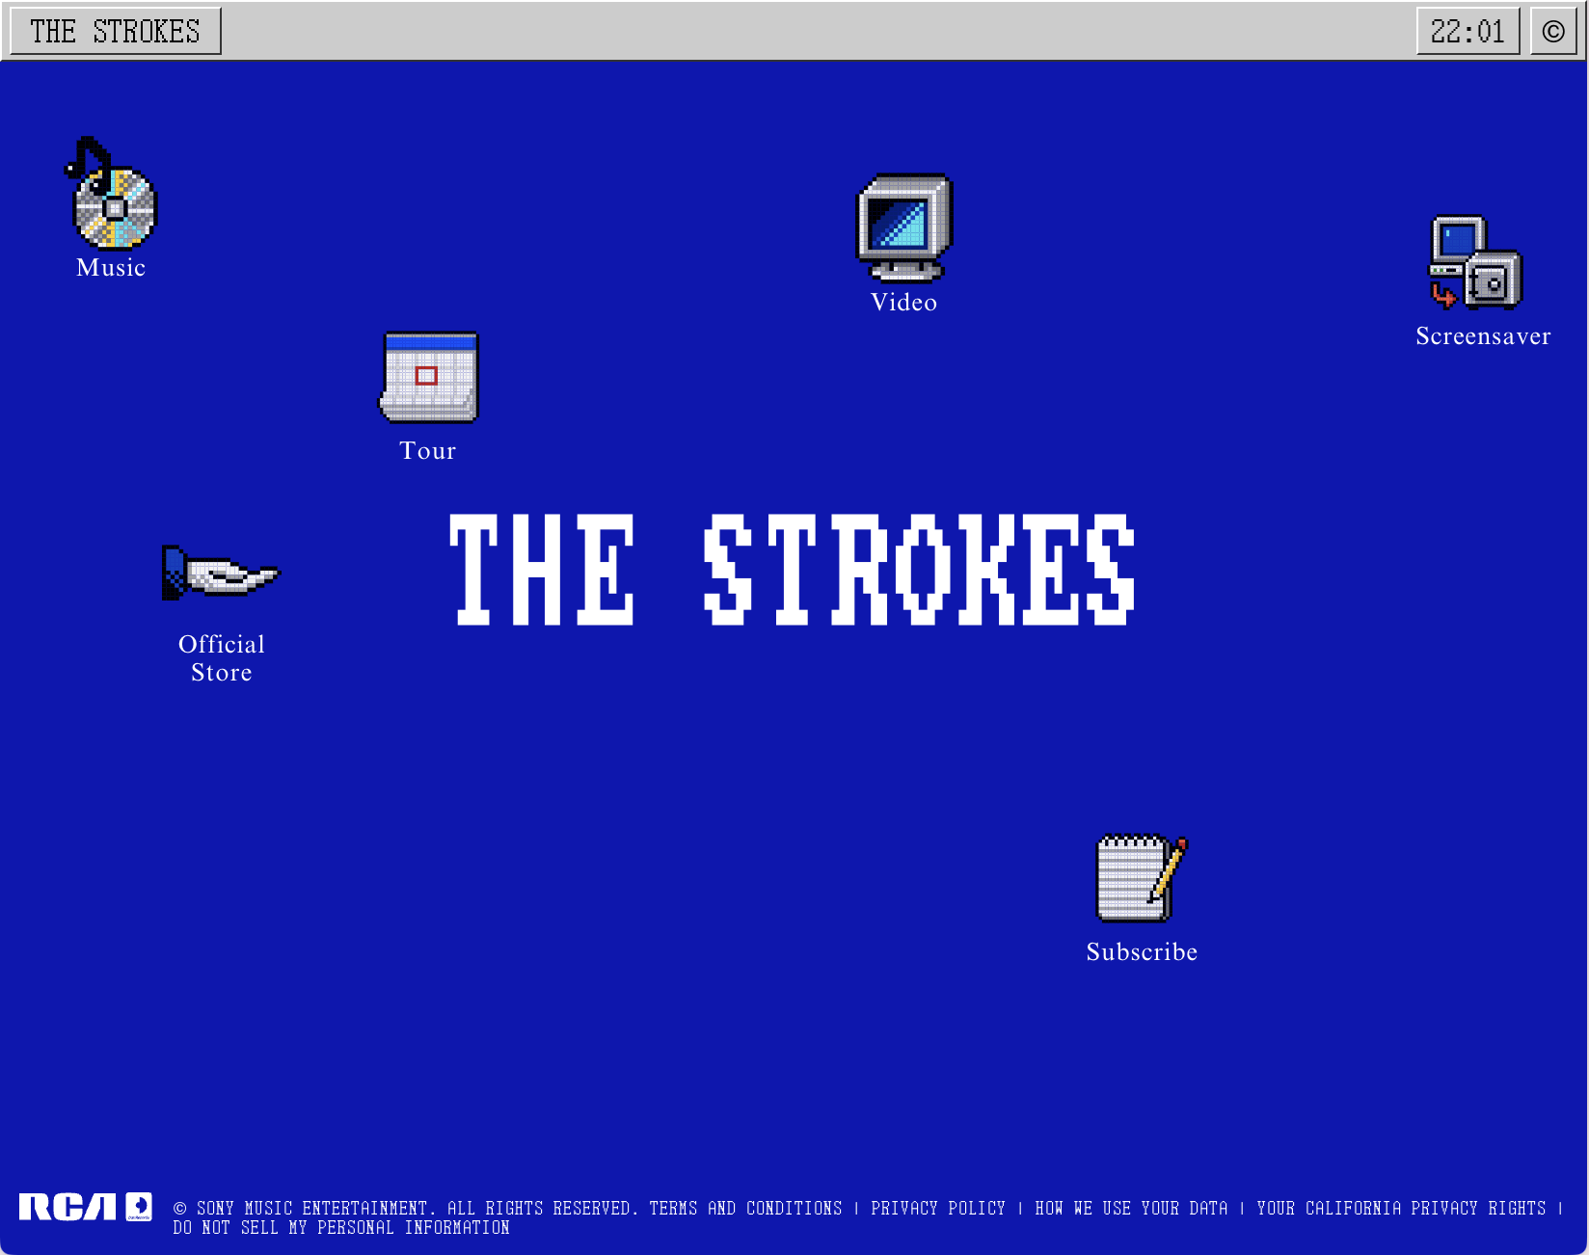

# onstage.md

## 2025-03-05 Csongor: Clash?

Maybe I’m too fast with me spreading out the conversations into different files, but I felt we need to start to talk about what might happen on stage and live during the exhibition.

was in Albuquerque giving a talk at the [ARTSLab](https://film.unm.edu/facilities/artslab/) at the University of New Mexico which included some reflections on the *It is as if* series and ended up with a little bit about *Phone* and even *Person*.

One of the things that makes me so excited about this issue of Devolution - besides the fact that it’s you! - is the opportunity to do more than the routine of the last few issues, more than a post mortem. To be able to reflect not just indirectly but more directly on how games *grow* out of the *stuff they are made of*. Any chance you could include that?

If you have a short description of your talk at the ARTSLab, feel free to add it to ../onstage/readme.md. We can expand it from there.

We have about 45-60 minutes of stage time in total, so what do we do with the rest?  
I have two suggestions, would be curious to hear what you think:

Either: another talk that expands the idea, shows a new POV on the same topics. I don’t have any particular names in mind, but I’m sure we can find someone great.  
Or: we interview / discuss with each other. In general, I don’t like the idea of putting myself on stage too much, I usually try to avoid that. But I see this more and more as an intersection, so it could work. And we would only have a few minutes, so if it goes wrong, it will be over fast.

## 2025-03-28 Pippin: Years later

Years later I reply.

I feel like me doing that existing talk won’t reeeeaally be a fit? I mean it’s a good talk and I think fairly entertaining… but not necessarily on target in terms of our objectives with the exhibition? If we want an “easy” “Pippin just talks about his work” kind of a thing, I have that locked and loaded, so maybe that’s vaguely reassuring.

However… I do kind of like the idea of us talking? Maybe with a third as you mentioned somewhere I think? Though if you’re not too excited about being on stage I’m not going to be the one to put pressure on you about it. But it could be kind of nice… an open conversation about design processes from our perspectives? With some visual aids - I can rifle through process documentation, profile MDM, you can talk about game gardens and devolution? Feels like there should be a lot of material in there to just… talk? (Without veering into that terrible version of presentation where people just show up unprepared and it’s all janky?)

And I suppose as some sort of third option I could try to concoct a talk that’s more grounded in process and MDM… I don’t have a *good* talk loaded up like that. I did quite an extensive one about *v r 5* but… I don’t think it landed in a good way. It was a bit stiff and boring. I’d have to return to the drawing board to think about how to make something like that a bit lighter and funnier…

So what do you think?

* Pippin does the classics! (Not too related to devolution, more just a recap of 14 years of making games + themes)
* Pippin and Csongor talk process and making design visible
* Pippin comes up with some sort of process talk and just delivers that, maybe a shorter one and you and I have some conversation afterwards to activate it a bit more and fold into a talk with the audience

Do we need to sound exciting? Could we be humiliated and nobody comes? :)

## 2025-04-01 Pippin: Post-meeting

Just want to plant a tiny flag here after our meeting this morning and including Zoewi’s (in this exact moment I’m like… is that how I should write her name??) ideas.

Seems like “Pippin does the classics” is a no, which I’m good with.

Feels like Pippin and Csongor chat is good, especially if we can add another voice.

And my immediate thought for a structure (please edit, riff) is something like:

* Pippin talks about a design exercise in relation to some stuff he does. I’m thinking in the immediate term about one version of the “variations” idea as in PONGS, BREAKSOUT, SNAKISMS, SNAKISTS, etc. all capitalized, huh. The objective would be to have audience thinking about the relationship between ideas kind of taken from elsewhere (the dictionary, say) and the language of a game… and what happens when you push them together over and over again.
* Audience does this work with a specific example. We pick a game form (something simple, maybe prechosen to make it easier) and we pick a means to get ideas from elsewhere (a dictionary, an encyclopedia, random youtube videos, whatever) and then people call out one line game designs or something.
* Maybe we even pick a couple and explore them further down into a design process. Obviously we’re not going to actually implement anything but we can think more seriously about the implications and fit to the game language and so on.
* And then after we’ve done that stuff we have a conversation about design process? Maybe Csongor and unspecified guest are involve in this thing at every step? (Mostly wrote myself in to not assign work, but I think it could be more fun if it’s an everybody thing?)

There’s something slightly unsatisfactory about this for me right now but I can’t quite name it. Maybe a bit too chaotic. Not sure. Not sure.

## 2024-04-11 Csongor: The Flag!

Yes, I had the same feeling after the meeting. Lots of good ideas, but no sense of a resolution, no satisfying unity of thought.

But why is this happening? How do you overcome flags, how do you get to the other side?  
But these are the big questions again, interesting, but we have a puzzle to solve.

Just a few more ideas, thinking out loud:

We could connect on-stage more with *The Designer Is Present*.  
Either by having on-stage at the beginning (of A MAZE.) where you could integrate the audience’s input into the design of the game you are working on, by starting to draw ideas! Like an *intro*, the *start*.  
Or the other way around: having on-stage as a looking-back at *The Designer Is Present*, a post mortem, a reflection. In its purest form: you could just sit there and write the journal.

Or we could go in the opposite direction and just make things simpler: three stages (you, us, drawing) is too much for such a short session. Maybe two would be enough / clearer / more focused?

Still no resolution… is this a case where writing is not enough? Let’s meet again!

## 2025-04-14 Pippin

Glad to see that you are also sometimes writing 2024 still this deep into the year. I feel like I do it at least once a day?

HMMMMMMM okay. Yeah agreed on the time. I’ve never been able to get over my sense of panic about not filling time so I always overdo it with the “content”.

Simple is good. I like the idea of a kind of codesign thing actually, bring the audience into the process. It feels like a massive leap of faith to me - what if nobody wants to be my friend :( :( :(

However, what about…

* Pippin is on stage working on the game (currently it would be It is as if you were playing a text adventure – I’m chatting to Michael Berto about this because it involves a work of his as the world of the story) – his screen is being broadcast while he does stuff
  + (In the terrible situation that Pippin has either finished this game or is too far in or something by the time AMAZE rolls up, I pivot to another game in the series and do all of these same things for that one instead - I do have what I think will be a good backup)
* Once it’s time to start Pippin “notices” the audience and introduces himself
* Pippin explains the game that he’s working on, showing elements of the existing process documentation to illustrate what’s going on; he especially outlines the current live problems/design stuff he needs to think about and asks the audience for help/conversation about it
* Pippin and audience work on the game together - probably more in a design mode (writing things down, drawing if needed [maybe we can have an easel and a big piece of paper, maybe I can just draw on my screen poorly]), Pippin makes changes and commits and so on and the game moves along with the audience input
* This might drag for 45 minutes, or it might not? Hard to say?
* Plausible extra - at some point Csongor wanders in (for whatever reason I’m wanting a sitcom style laughtrack+applause when you enter?) and checks in with Pippin, asks how it’s going; Pippin explains what’s been happening (as if Csongor hasn’t been there I guess) and then they have a conversation about this in perhaps a broader context of exhibitions of videogames… dot dot dot…

I kind of like this in a more solid way, though I do fear it because it’s very solo performance for a lot of it. Though that said it’s something I for sure know how to do.

## 2025-04-26: 👀

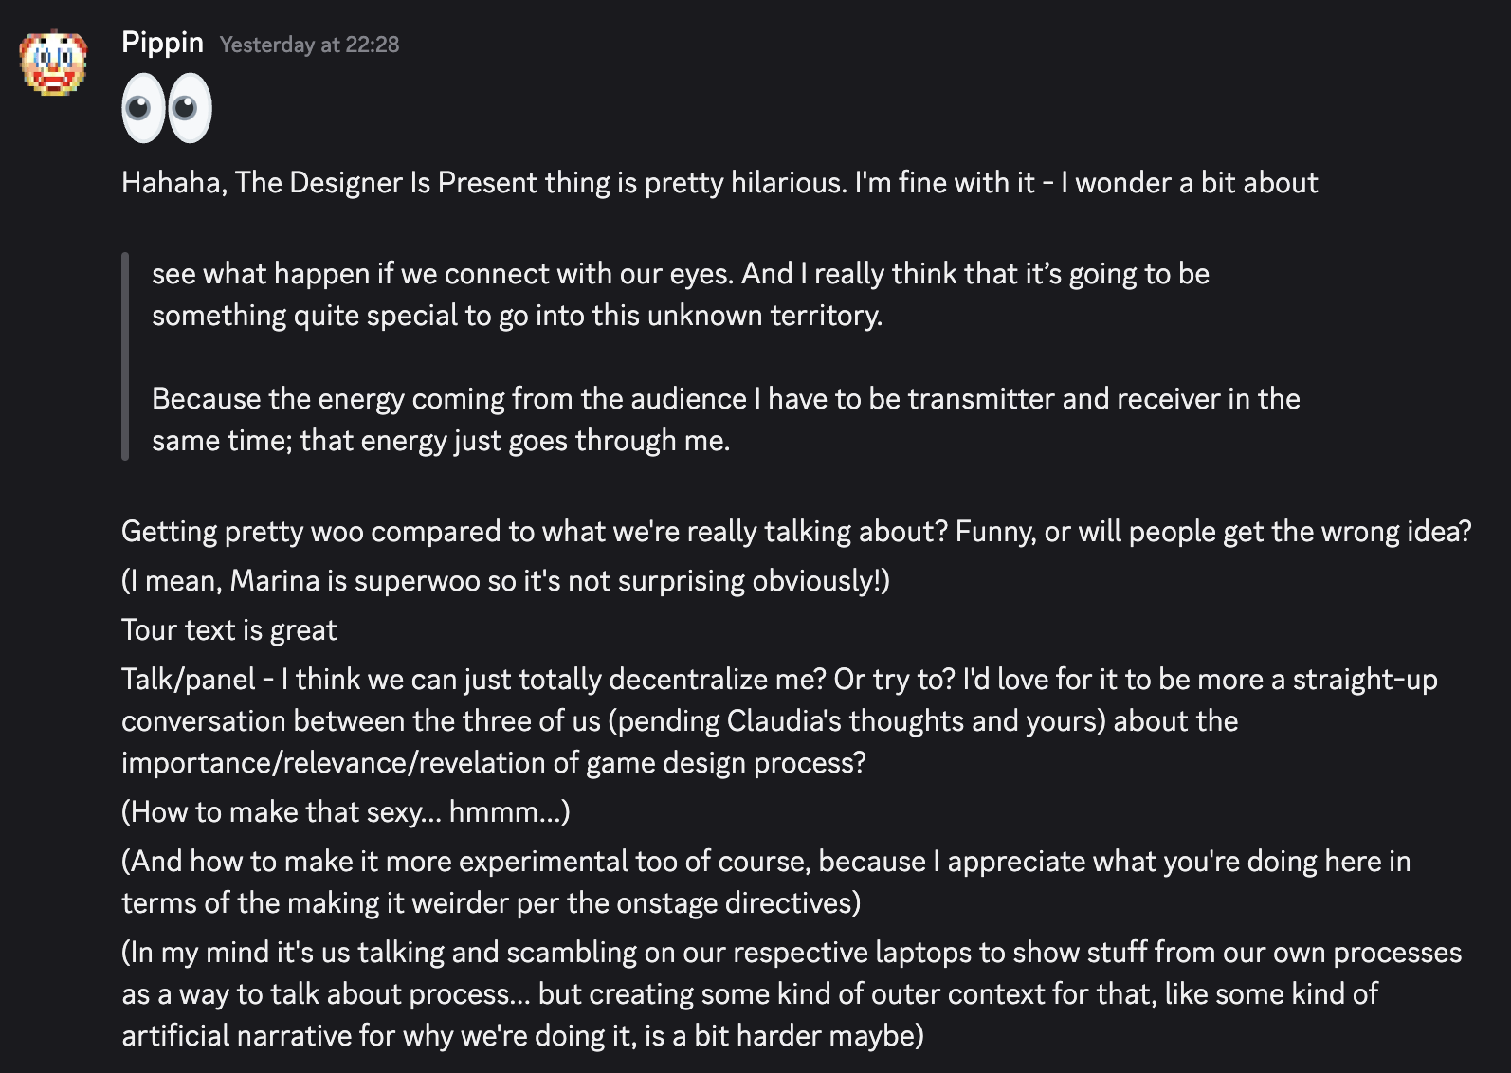

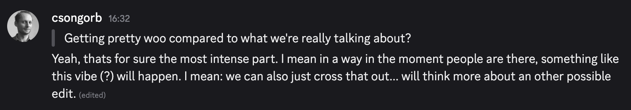

# Program?

Reminder, this is what we need:  
https://2023.amaze-berlin.de/schedule/  
(Filter by “Devolution”.)

Supposedly this year they will show up here:  
https://2025.amaze-berlin.de/schedule/

For all bios, see [bios.md](./bios.md).

## The Designer is Present

When?  
- Thursday, 15 May 2025: 1 to 3pm  
- Friday, 16 May 2025: 1 to 3pm  
  
Who?  
- Pippin Barr  
  
Type / Tag:  
- Devolution

In The ~~Artist~~Designer is Present, I perform every day for ~~three months~~two days. The performance is really about presence *and speculative play and developing some new iterations for an* ***It is as if you were…*** *games*. You have to be in the here and now, 100 percent.

~~I have the empty chair, so~~ everybody from the audience can come on his free time and ~~sit in the front of me, and~~ engage in this kind of ~~silence, experience of the~~ here and now, the present moment.

So you can observe this as a kind of stage for experience. Or you can really enter that space and take active participation, which actually bring you much closer to the artist, and this presence, and to your own experience.

~~If you sit on this chair opposite of me, it’s extremely important to actually find a very comfortable position and you don’t move. Just sit motionless, and~~ see what happen if we connect with our eyes. And I really think that it’s going to be something quite special to go into this unknown territory.

Because the energy coming from the audience I have to be transmitter and receiver in the same time; that energy just goes through me. ~~And to be ready for the next visitor and the next one and the next one.~~

(Title & description -obviously- based on / inspired by [Marina Abramović](https://www.moma.org/audio/playlist/243/3133).)

The tour is a part of [*Pippin Barr x Devolution: It is as if you were…*](https://github.com/csongorb/growingstuff), a cooperation between [Pippin Barr](https://pippinbarr.com/), [Devolution](https://devolution.online/), A MAZE. / Berlin 2025 and [UE University of Europe for Applied Sciences](https://www.ue-germany.com).

## Exhibition Tour with Pippin Barr: It is as if you were…

When?  
- Thursday?  
  
Who?  
- Pippin Barr  
- Csongor Baranyai  
  
Type / Tag:  
- Devolution

**Capacity for this session is limited, spots will be assigned on a first-come first-served basis: we recommend meeting in the Devolution exhibition area at least 20 minutes before the starting time.**

For the ultimate insight into the development of the *It is as if you were…* series and its design decisions. Guided tour through the exhibition by Pippin Barr and Csongor Baranyai, the curator of the exhibition. Complementing the exhibited games and versions with background information, secrets and anecdotes.

*It is as if you were…* is an ongoing game series of short and experimental games by Pippin Barr, started in 2016.

The tour is a part of [*Pippin Barr x Devolution: It is as if you were…*](https://github.com/csongorb/growingstuff), a cooperation between [Pippin Barr](https://pippinbarr.com/), [Devolution](https://devolution.online/), A MAZE. / Berlin 2025 and [UE University of Europe for Applied Sciences](https://www.ue-germany.com).

## It is as if you were attending an experiment

When?  
- Friday?  
  
Who?  
- Pippin Barr  
- ?  
- Csongor Baranyai  
  
Type / Tag:  
- Devolution

An experimental session: half performance, half a talk, half a discussion, half live development, half workshop. It will somehow contain glimpses of Pippin Barrs ideas flowing into his games, might contain parts of developing ideas together with the audience, for sure including some reflections on the stuff games are made of and how they influence the development process. Three voices merging into an experience (at least for them). Or also for you?

The talk / panel / session is a part of [*Pippin Barr x Devolution: It is as if you were…*](https://github.com/csongorb/growingstuff), a cooperation between [Pippin Barr](https://pippinbarr.com/), [Devolution](https://devolution.online/), A MAZE. / Berlin 2025 and [UE University of Europe for Applied Sciences](https://www.ue-germany.com).

## Devolution Exhibition - Pippin Barr: It is as if you were…

The exhibition focuses on the development process of the *It is as if you were…* games of Pippin Barr by displaying several games of the series, incl. in-between versions, from early prototypes to later iterations. Visitors can explore the creative process behind the development, encountering new insights with each version they play and each comparison they make.

Looking at games and game development from the perspective of Devolution lets the visitors discover new and inspiring aspects of how games are growing into shape and what this means for game design and development and digital media in general. In contrast to the usual reception of the finished end result, Devolution reveals the whole road up to them, providing valuable insights to the visitors.

The exhibition is the core of [*Pippin Barr x Devolution: It is as if you were…*](https://github.com/csongorb/growingstuff), a cooperation between [Pippin Barr](https://pippinbarr.com/), [Devolution](https://devolution.online/), A MAZE. / Berlin 2025 and [UE University of Europe for Applied Sciences](https://www.ue-germany.com).

# The Dessauer Press

## Message to Jesse 2025-03-10

Dear Jesse,

(as always) sorry for the long gap, I needed a while to collect my thoughts. I’m just thrilled that you’re willing (inspired?) to join us and help with the booklets, the style, the orga. Very much looking forward to this!

A kind of manifesto on everything booklet-related:

1. The more I think about it, the more I think in terms of a zine rather than a booklet. I am not at all sure if this is a proper distinction, but what I mean is that a zine is something more “unfinished”, work in progress (as opposed to a booklet, which is very much finished). This needs / should be represented both in structure (some zines need to be open-ended and we need to be able to add to them during the exhibitions, new pages, drawings, etc.) and content (somehow I’m afraid of too much finishness, too much perfection, would prefer something where being rough is still ok).
2. The booklets / bundle of booklets needs to represent some kind of a merge of two ideas. Until now, Devolution was always a “Devolution of…”, we have picked a game and observed / examined it. This time it feels more like a merge / cooperation / crossover of two ideas:

* https://pippinbarr.com/
  + his ideas in https://mitpress.mit.edu/9780262546119/the-stuff-games-are-made-of/
  + strong visual style, both his website, but also the book
* https://devolution.online/
  + unfortunately we changed our visuals / style a lot during the last iterations, with the branching logo (https://devolution.online/devolution7_lmd_2023/) being the last version, we have tried to understand the branches as something that can grow, even had stamps https://devolution.online/wp-content/uploads/2023/11/IMG_8102-e1737123756942.jpeg

…through the example of:

* *It is as if…* series
  + a series of games, all variations on similar topics, has evolved over time
  + consisting of 5 - 6 games, most of them aesthetically separable in two directions:
  + the games more recent *Phone* and the old *Chess*
    - https://github.com/pippinbarr/it-is-as-if-you-were-on-your-phone
    - https://github.com/pippinbarr/it-is-as-if-you-were-playing-chess/tree/main/info
  + *Work* and *Love* are heavily referencing by MS Windows
    - https://github.com/pippinbarr/itisasifyouweredoingwork/tree/master/info
    - https://github.com/pippinbarr/itisasifyouweremakinglove/tree/master/info

1. The idea is to have a booklet/zine for each game, plus an additional meta-booklet and maybe an empty notebook for reflecting practitioners.
2. The main content for most of the booklets will be the journal from the corresponding game (an example: https://github.com/pippinbarr/it-is-as-if-you-were-on-your-phone/blob/main/process/journal.md), but accompanied by some additional information / material (commit messages, source code, images). A collage, structured over time, with a strong main thread (the journals).
3. Since I suspect that the style of the booklets will be amazing and visually strong… I think it is safe to say that the whole visual style of the exhibition needs to be informed / inspired by it… how can we do this?

I think / hope thats it. Looking forward to discuss, not sure about half the things I wrote about.

## Message to Jesse 2025-04-19

Dear Jesse,

again, thank sooooo much, [this](./tests/LoveTest_250418.pdf) is such an awesome version already. Interesting to see of your changes, your point of view adds so much.

We just had a longer discussion and here are our observations, starting with simple ones:

* most images do / will NOT have a caption, I think it’s easier to not work with that
* I / we have a similar feeling with the upper right/left corners “It is as if you were making love”
  + on the one hand I feel it’s just not so much needed, and it’s also killing a lot of space
  + but I also don’t fully “get” the logic when its there and when not, maybe I just misunderstand?
* Table of Contents
  + thats just not easy… generally, I feel it looks gooood, BUT:
  + the idea was to use a Pippin-style TOC, resembling his readme-structure
  + which would be the first bullet-point list of the redame section (incl. the brief descriptions) AND the page-nr. next to them… maybe I can / should visualise it?
* With or without “.md”
  + hm, I get your reasoning behind excluding them… need to think about it more, but yes, maybe we can just leave them out, the idea behind them is… very nerdy and not too clear
* Restructuring / merging Info & Press Kit
  + hmm, thats again not easy, as I tried to aim for a nice balance between “preserving” and “not-repeating”
  + for example, I kept the “Who is this Pippin Barr guy?” because he has a new version of it for each booklet, so there is a “progress” and for us exploring such progress is… essential?
* Imprint & such
  + yesss, you are already very much more on point than I ever could! thanks!
  + small changes in production team, will let you know when we have it

We made a new version [again](./2018_love/_book/), except the todo-chapter: done.

Such things. Lot of details. Let’s talk? Looking forward for sure!

## Jesse > Csongor 2025-04-20

Hi Csongor,  
Thanks for the feedback … and, of course, I’m glad to hear you’re generally happy with the way things are going. I think most of what you wrote in your message can be distilled to a single question: to what degree do we want to preserve the structure and apparatus of the original digital form, and to what extent should we adapt it to the restrictions of a physical book.

As you know, my own background is in classical (i.e. physical) book design, which has its own rules and conventions that I have (somewhat unthinkingly) applied to the booklet design; I confess that I am wholly unfamiliar with the format in which you are working, although I am aware that your field – as with all specialist fields – has its own vocabulary and its series of conventions that make sense to initiates but that seem utterly foreign to outsiders. All of which is to say that the current design is my attempt to find a common ground between your text and my own design approach, but that it has necessarily skewed in the direction of traditional book design.

So, for example, the running headers follow a very traditional scheme: they appear on all pages except important recto pages (in this case title, contents and chapter heads) … and in my own view they are not killing space so much as giving the pages room to breathe. The ToC follows the conventions of a traditional book – i.e. as a simple index – rather than the conventions of a “readme” which, although I don’t really know what it is, seems designed more for an environment in which you can click on the word “chapter 2” and be transported there instantly. (Also, full disclosure: I was absolutely confused by the purpose of that page … I kept it because it was part of the text, but you’ll notice that I shunted it off to a verso page because I wasn’t entirely sure what to do with it).

In short, your original text has its own structural mechanisms that allow the reader to “navigate” the text, while the printed booklet necessarily has a different set of mechanisms that serve the same function. Our joint goal is to figure out the best way to translate the text from one medium to the other … I suppose this is something we should have discussed ages ago, but I am confident we will be able to figure something out. Ultimately you know the audience for which these books are intended, and I want to make sure they reflect your vision.

I suppose the larger existential question is: if all of this information is freely available to read on the internet, why are we bothering to turn it into a book? The answer (for me, at least) is self-evident: the physical artefact is a tangible luxury in an age when texts exist primarily as zeroes and ones. But the value of these documents consists not merely in the fact that they are printed, but in the fact that they are edited and organised, sculpted into something permanent. I know that this goes somewhat against the ethos of the digital age in which everything is logged in real time and even errors become an important part of the process, but that, of course, is what makes the project interesting: like the letterpress-printed QR code that I showed you the other day, there is value in attempting to translate between media.

I include all of the above comments primarily in order that they may guide our remaining work. There is, of course, no right or wrong way to translate from the original format to the printed booklet … the only guideline is “does it work?” And if we are all in agreement, then it probably works.

In practical terms, I am happy to prepare a new version of the booklet with the size of the running headers reduced — this will, of course, have the side-effect of buying us a bit more space and thus making the booklet smaller. I am also happy to play around with the ToC, perhaps to find a hybrid approach (now I know that the “readme” was intended as a ToC this will make my work easier).

Regarding the “Who is this Pippin Barr guy” I really like this, which is why I removed it to the back where the “about the author” would traditionally be located, and there is certainly no problem if it changes from booklet to booklet. If you would prefer it near the front – perhaps on the verso opposite the press kit – I am happy to do this, but I would recommend keeping it separate. However I really liked the idea of having it as the last page of every booklet, and I was thinking you might also add a few sentences of your own under the header “…and what exactly is Devolution?”

I also have a request: the thing that took me the longest when designing the text in InDesign was standardising the format of dates (I had to retype them all myself); would it be possible for you to do this easily in the original files? I recommend the following: “Day, Date Month Year [forced line return] Time” … so: Sunday, 20 April 2025 13:48. However any format is fine so long as it is consistent (in the draft I set it switched midway through).

One final thing: the text, as it stands, is full of minor typos and errors, many of which cannot be caught by a spell-checker because they are, in fact, proper words (just not the right one). I have not been correcting these as a I typeset because I am aware that this is not the final draft … but if you can let me know when I have the final draft, I will start combing for typos as I set. Once I start this process, we will no longer be able to edit the original text, but must make all changes directly in the InDesign document.

I think that’s it for now. Hope you’re having a relaxing Easter weekend – it looks like a nice day out there – and I will try to send a new draft today or tomorrow incorporating some of the things we’ve discussed.

See you soon,  
J

## Jesse > Csongor 2025-04-21

Hello again.

Further to my last message (which, I realise, was rather long … I think it was Pascal who said that he wrote a long letter because he didn’t have time to write a short one) here is a new version of the Love booklet. I reset the whole thing from scratch, mostly to see how long it would take.

I also made a [few modifications](./tests/LoveTest_250421.pdf) based on your feedback:

— The ToC reflects your text more closely while still remaining within a traditional book structure — I’ve slightly amended the second half of the readme text and included it as “a note on the text” on the verso. I wasn’t sure who wrote this, but generally speaking when the text includes a “I” it should have the name of the author or editor underneath. — I’ve pushed the running headers to the top of the page and made the page numbers a bit smaller. This has allowed me to make the columns a bit wider. As such, the total extent of the booklet is now 64pp. Not bad.

There are still lots of minor design errors that will be ironed out in the final version, but I wanted to send this so that you could get a sense of how things are evolving.

See you soon,  
J

## Csongor > Jesse

Dear Jesse,  
this is just… just so awesome!  
Don’t really know what to say, that besides a few last more typo-like things this is all almost finished.

* the “a note on the text” has a quote in the original (maybe it got lost on the way?), can you keep that? we’ll have a few more quotes in the meta-booklet, maybe you need a style for that?
* about the dates… have tried to change them, but couldn’t manage. today my focus was on something else, but I can try tomorrow again

Also: most booklets are done now, feel free to start / continue with *Love* (fully finished!) and *Chess* and *Work*. Give me one more day to finish the others.

Aaaah, and also a few words about your awesome [Cover Tests](./tests/CoverTests_250419.pdf):



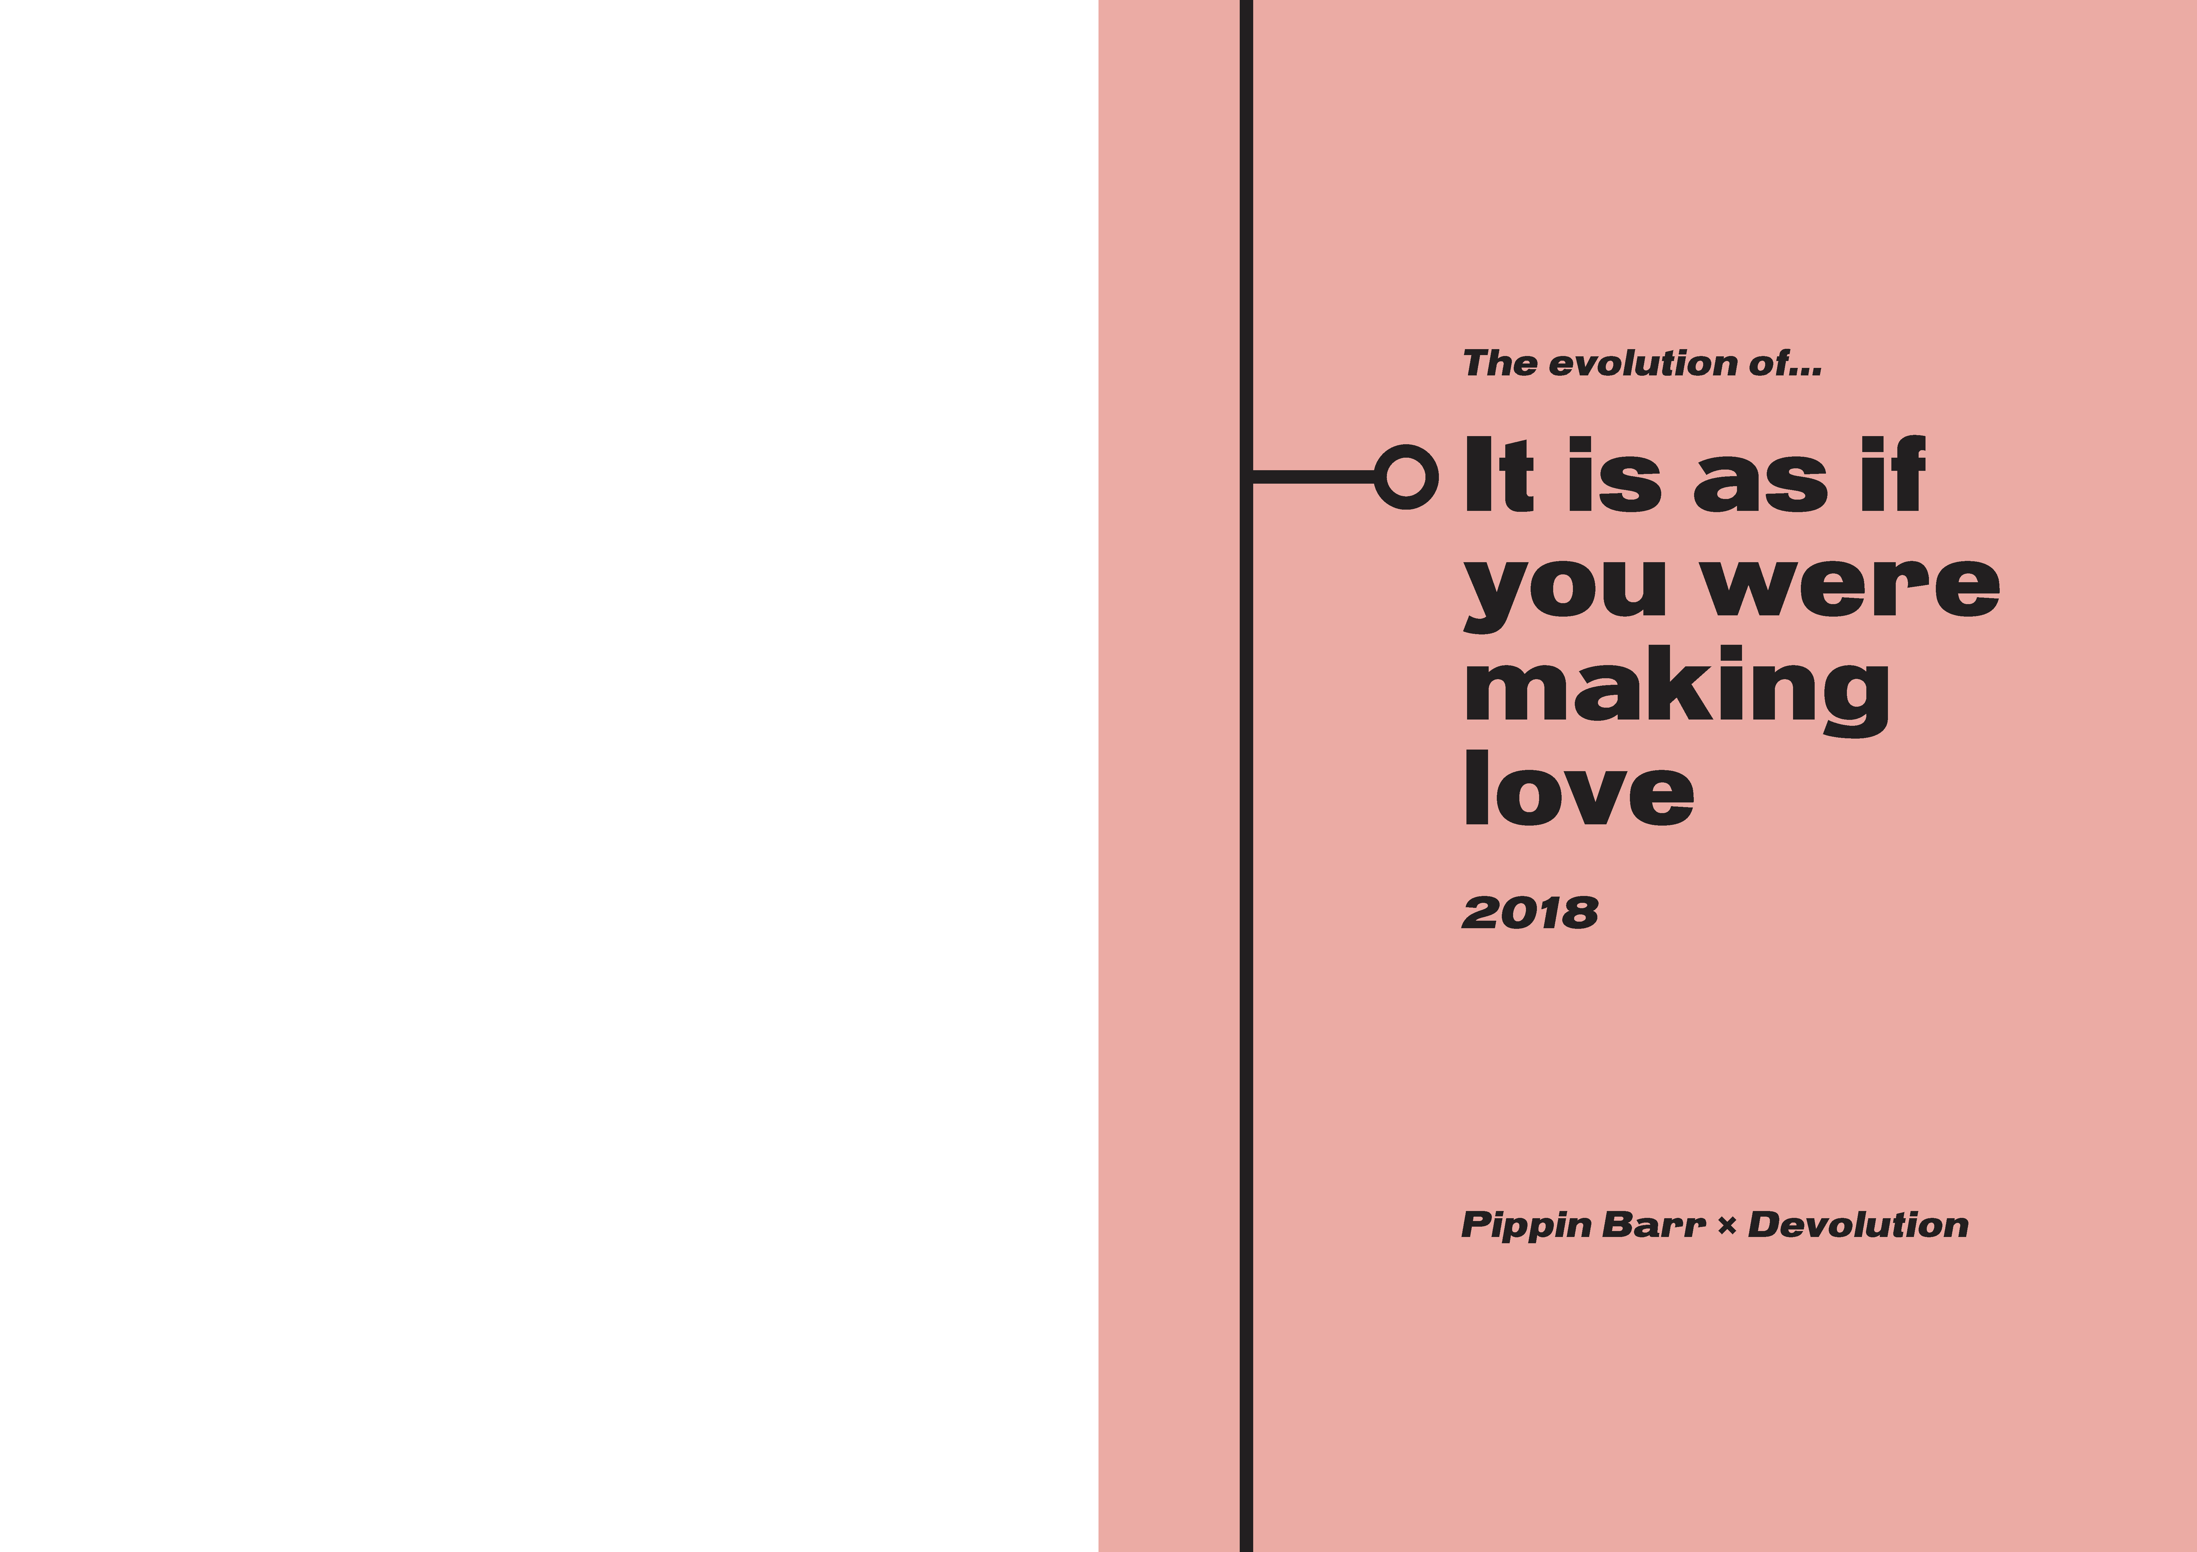

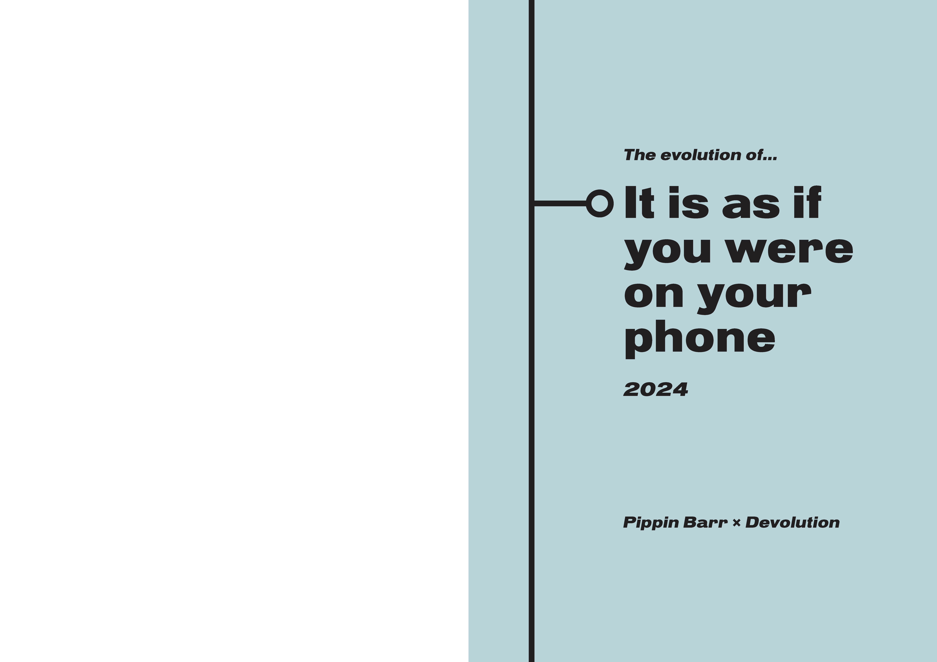

* my initial impulse was that the colors are one step too pale, but the more I look at it the more I like it
  + have the feeling I would like to see another one, just for options, but its just my ego
  + the last / brown one is… brown I suppose?
* text-wise I would like to add “It is as if you were…” to it and also “A MAZE. / Berlin 2025” to it, just for completion
* the line is… just awesome!
* missing one one one playful element on those,
  + not the emojis, but one graphical element per game?
  + or some pieces of the Devolution leaf?
  + something like this?

So happy, see you tomorrow!

# Miro boards

## 2025-02-28

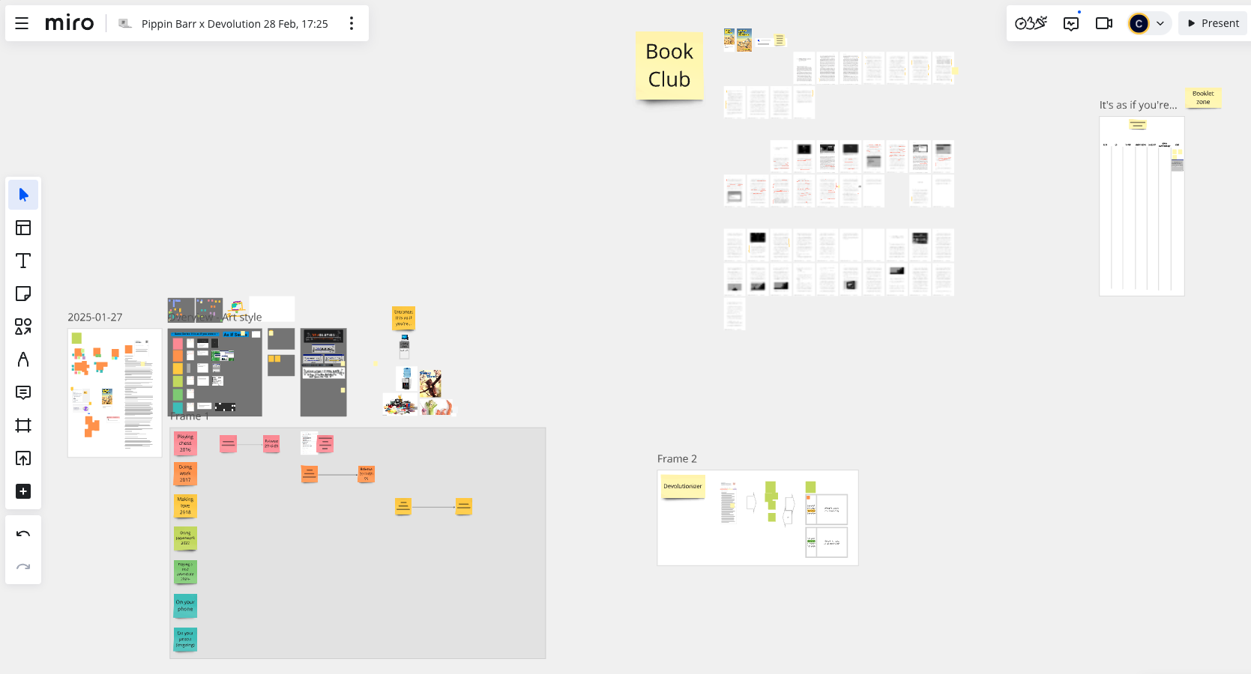

## 2025-03-05

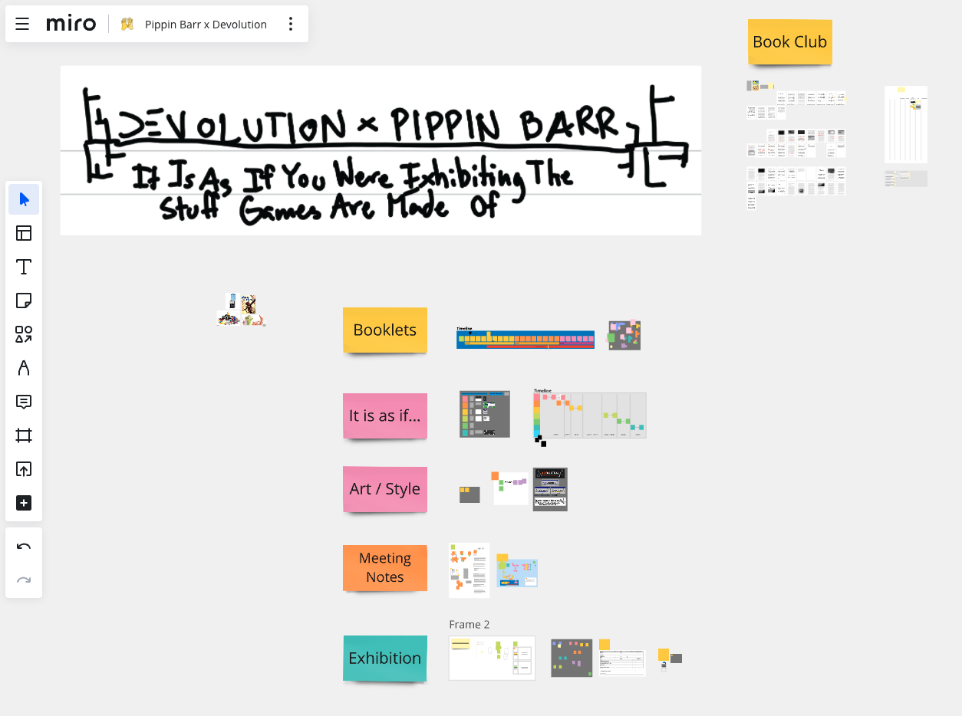

## 2025-04-05

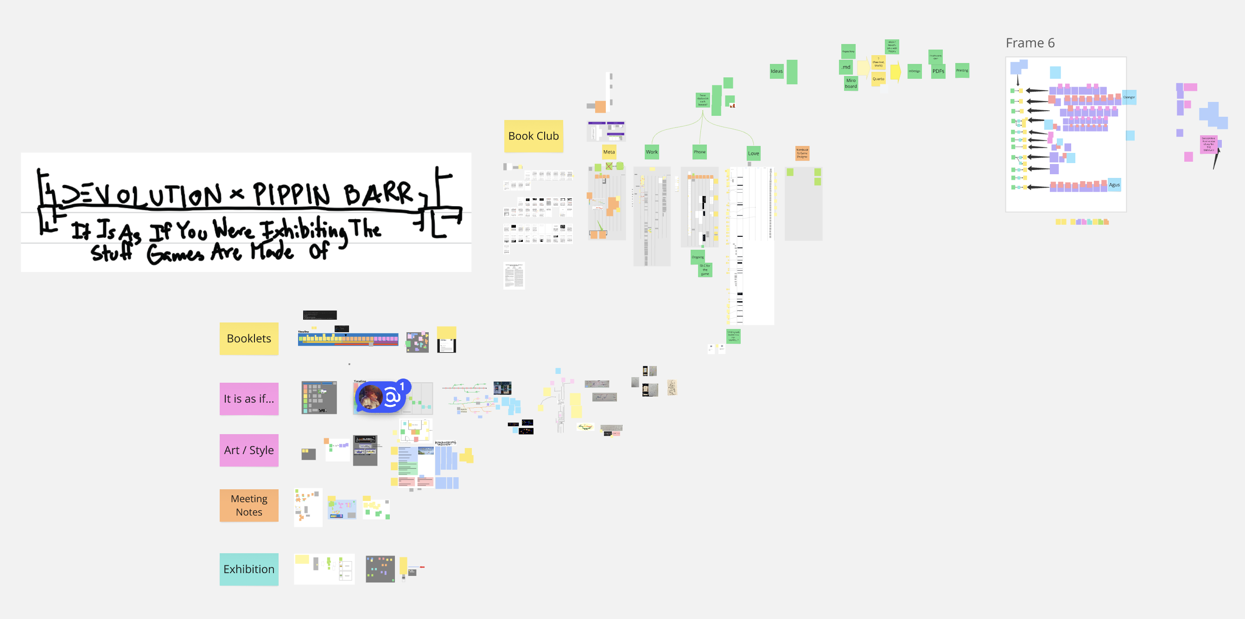

## 2025-04-14

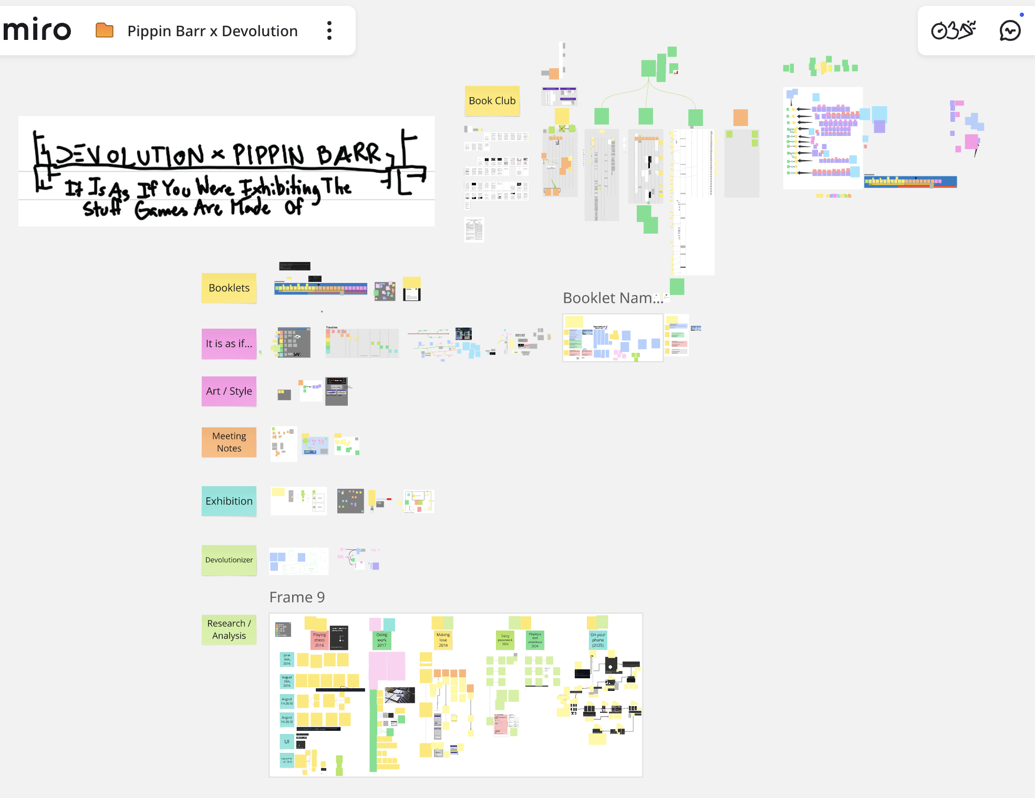

## 2025-04-25

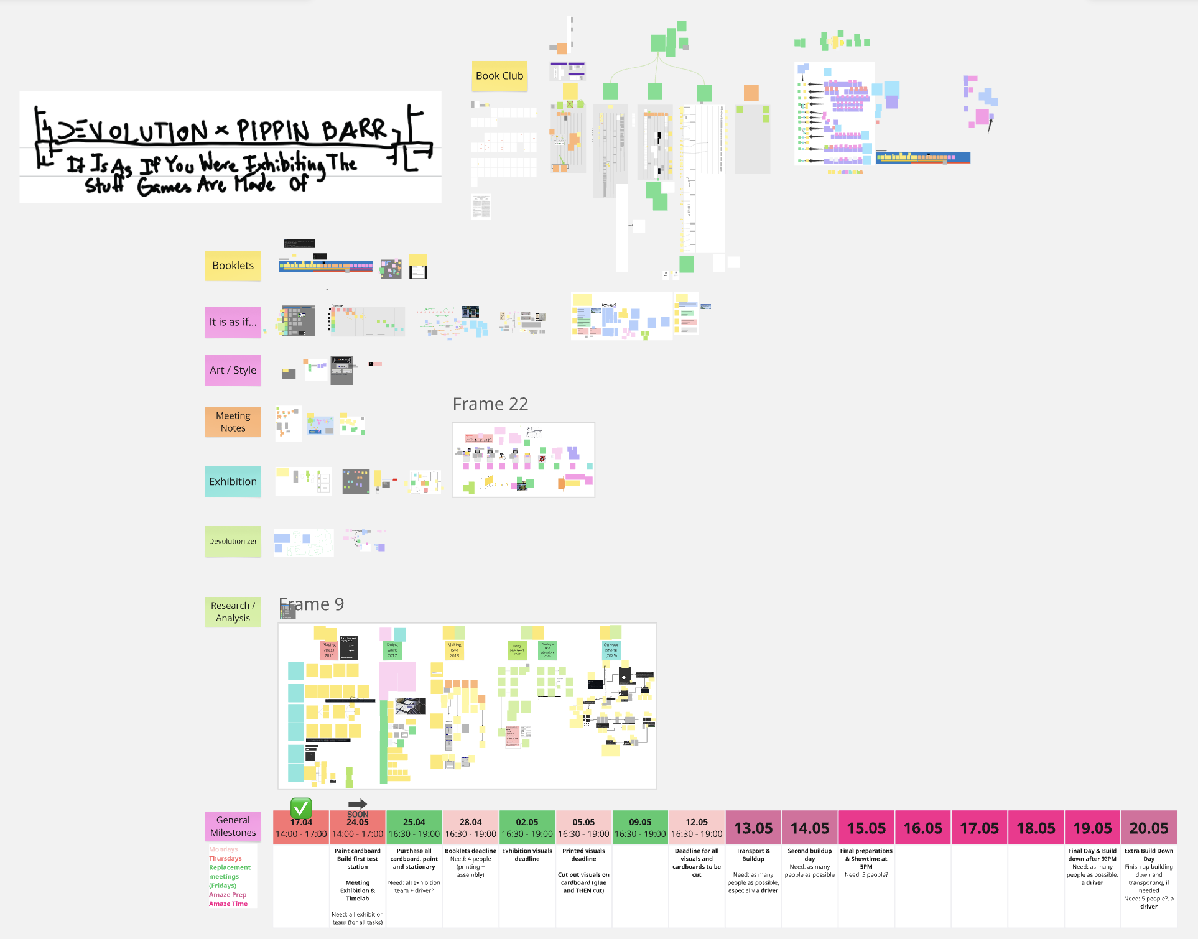

# Timelines

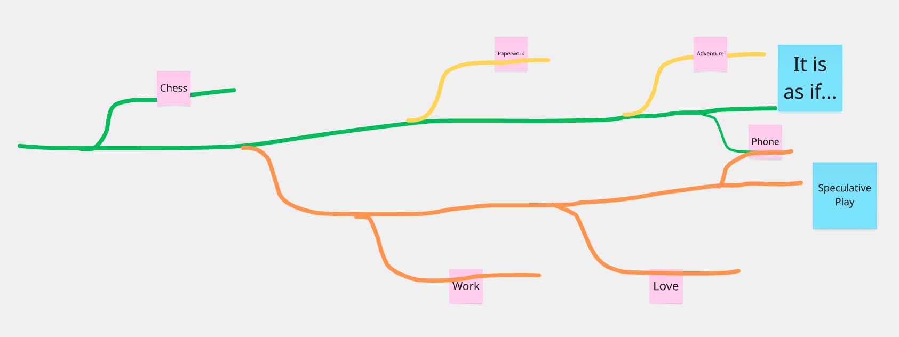

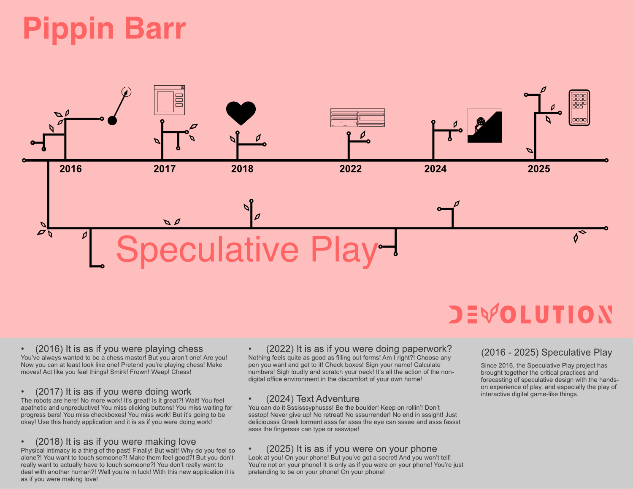

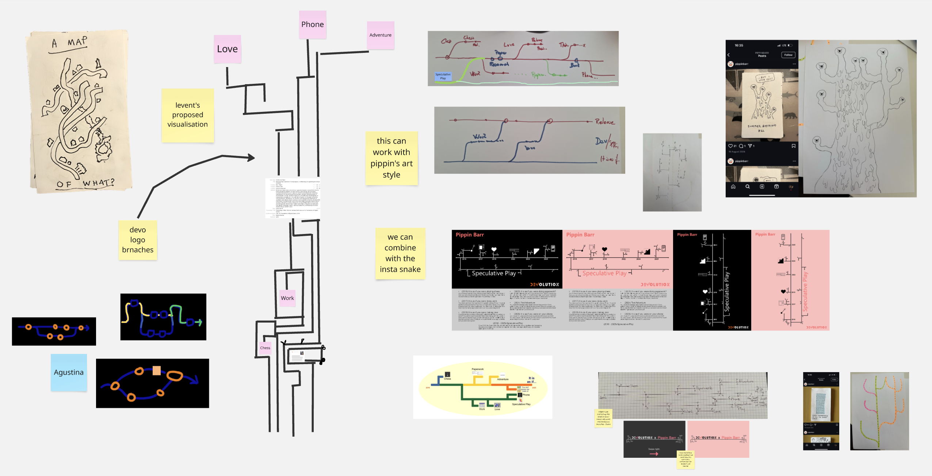

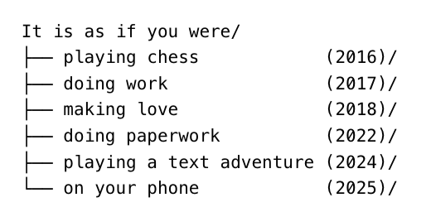

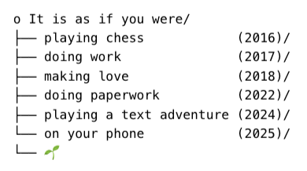

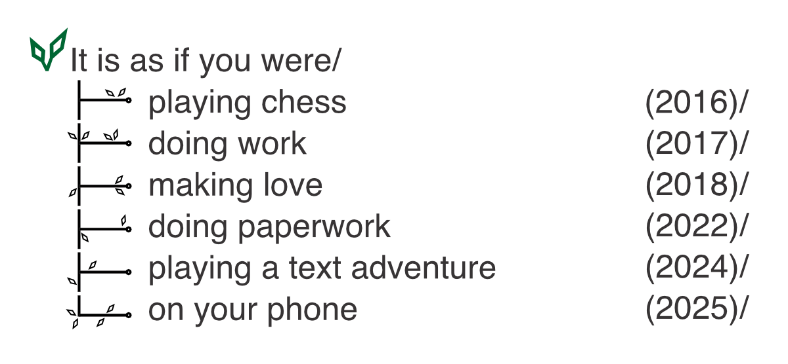

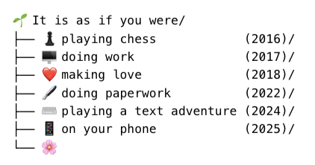

# Titles

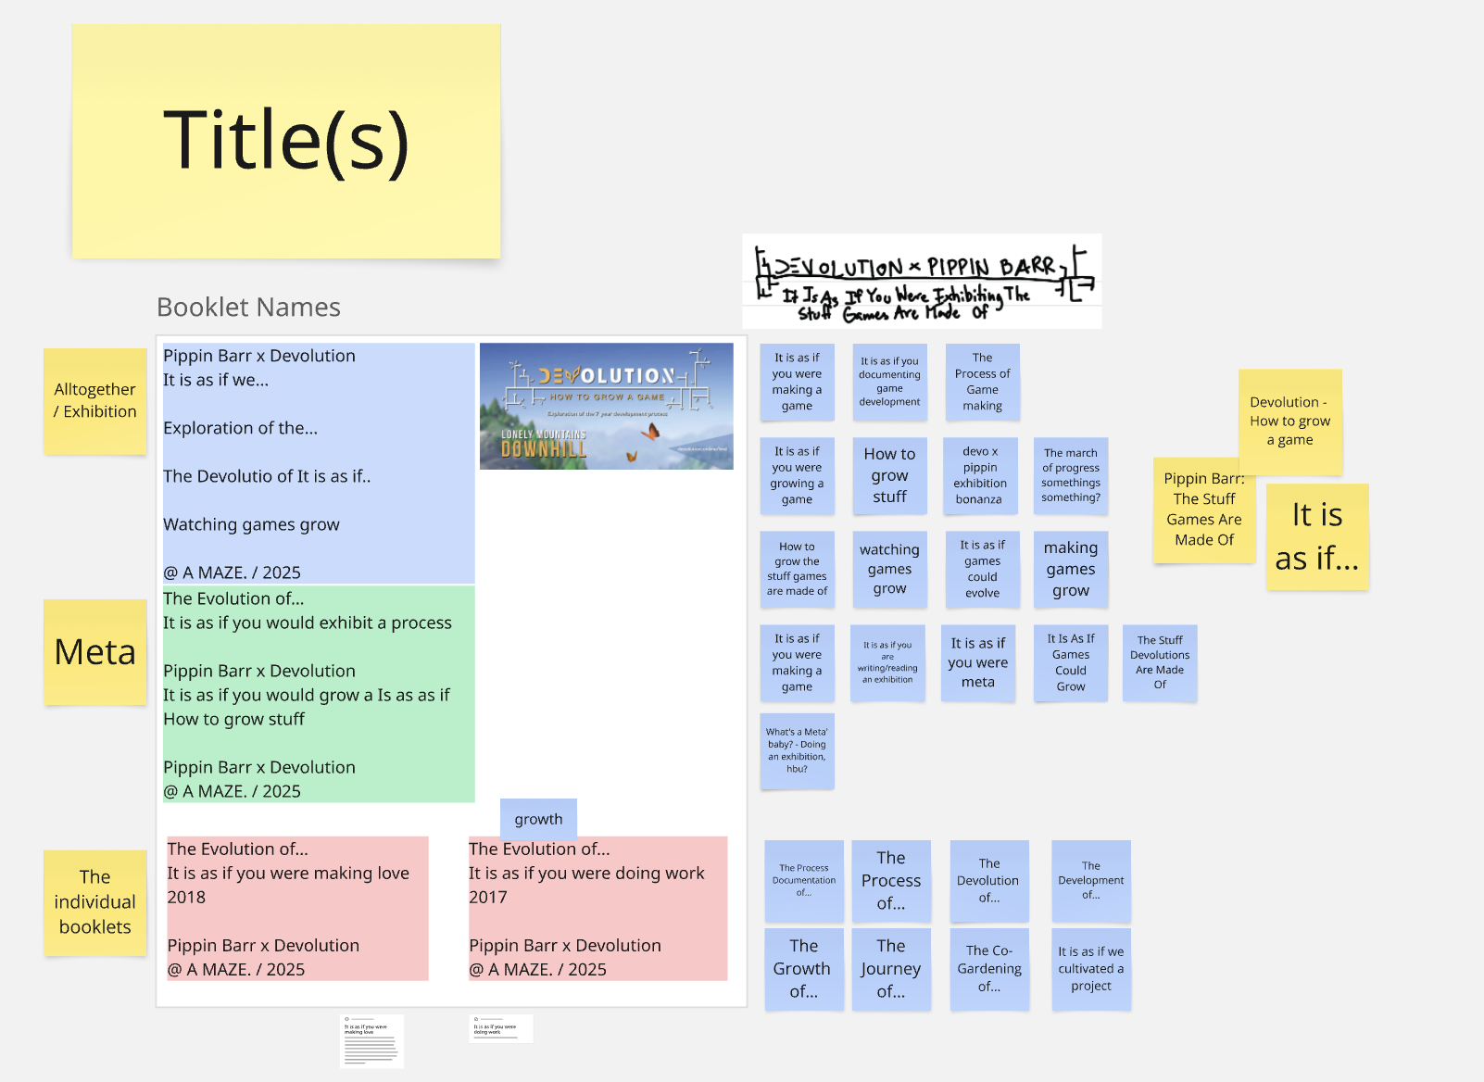

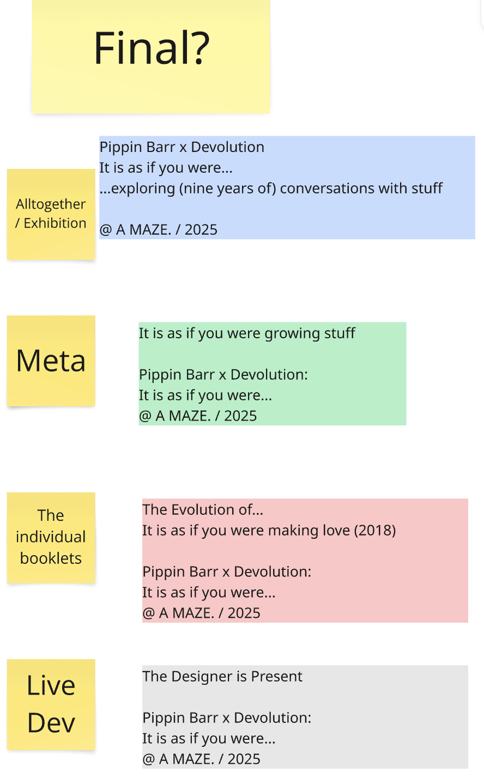

# Exhibitions

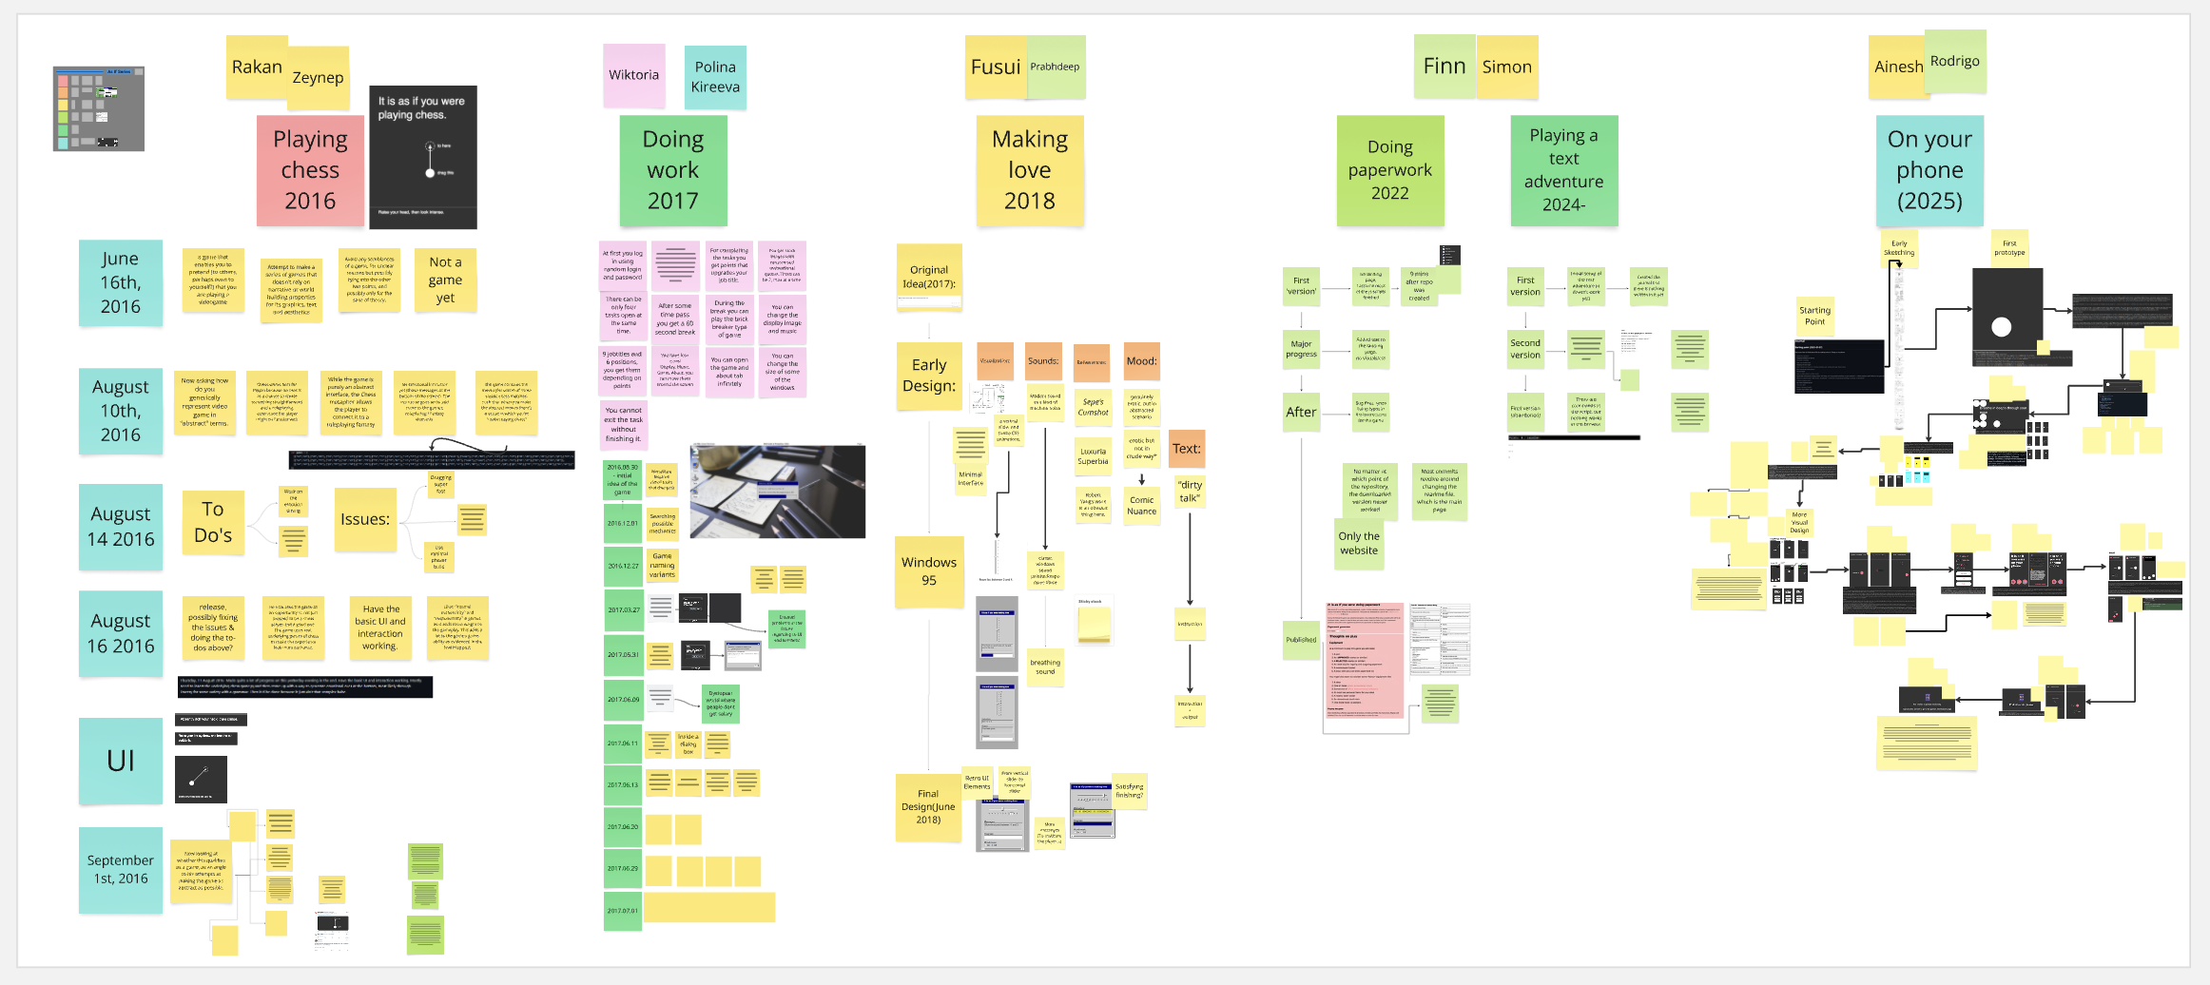

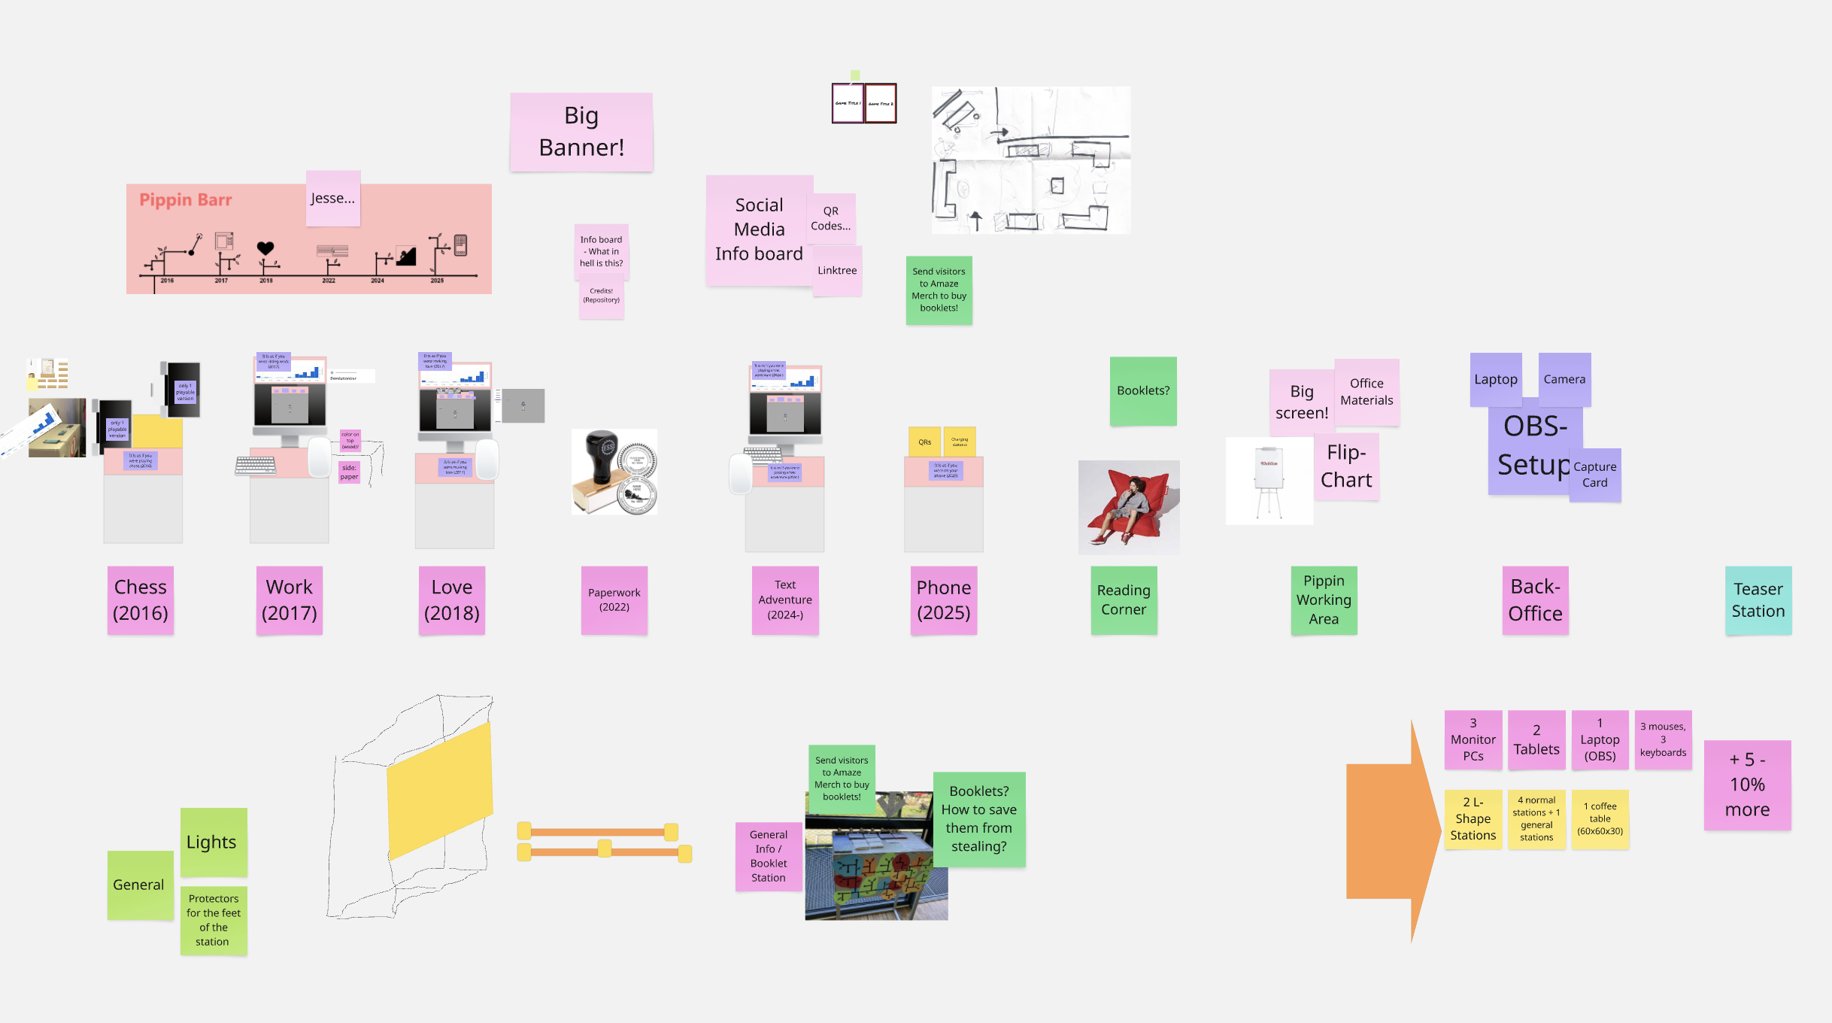

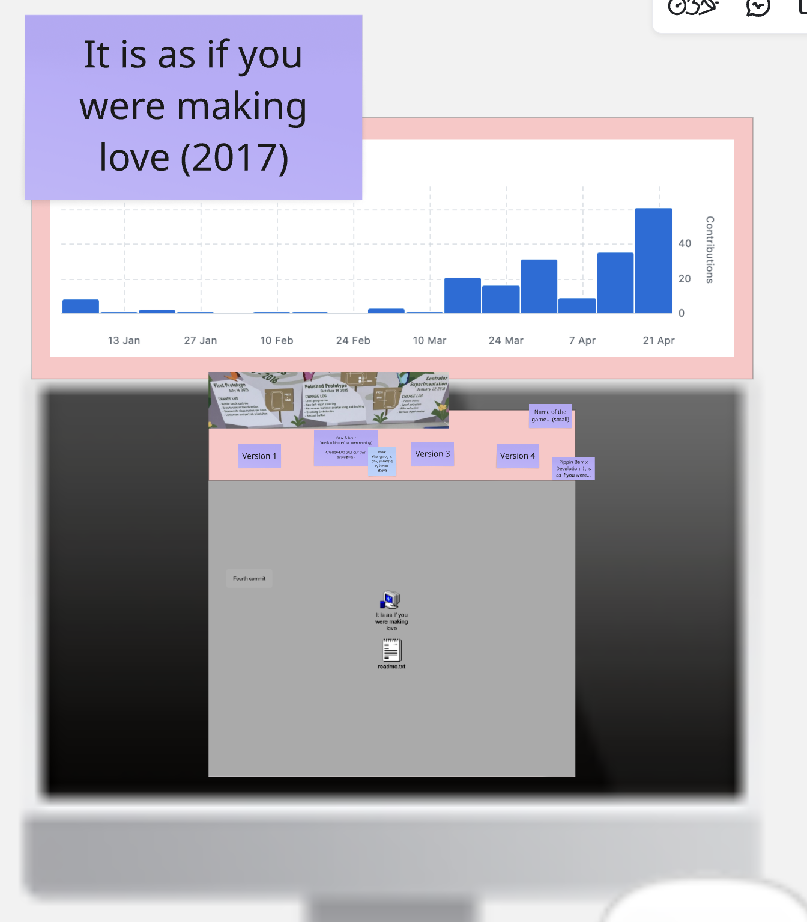

# Versions

## Early Questions

Which versions to exhibit for which game? How (PC, phone, tablet?)?

## 2025-04-05 Csongor: First Ideas

Which versions to exhibit? We have the games, but we also need to find the particular versions…

All / most versions will be exhibited through the [Devolutionizer](https://github.com/csongorb/devolutionizer), at least thats the idea.

Still, lot of open questions:

* can we add the versions directly to this repository? would that be ok? would that work? would Pippin be ok with it?
* can we let people play each version with a QR code?
  + or do we want to let them see the hub and select each version individually?
  + or both (individual solution for each game)

## 2025-04-22 Csongor: Shift & Focus on Player

Time is running short, so instead of making the full Devolutionizer, let’s focus on the Player only, thats the core of what we need.

Made a fast setup, it already makes a strange sense to be able to switch between the versions so fast

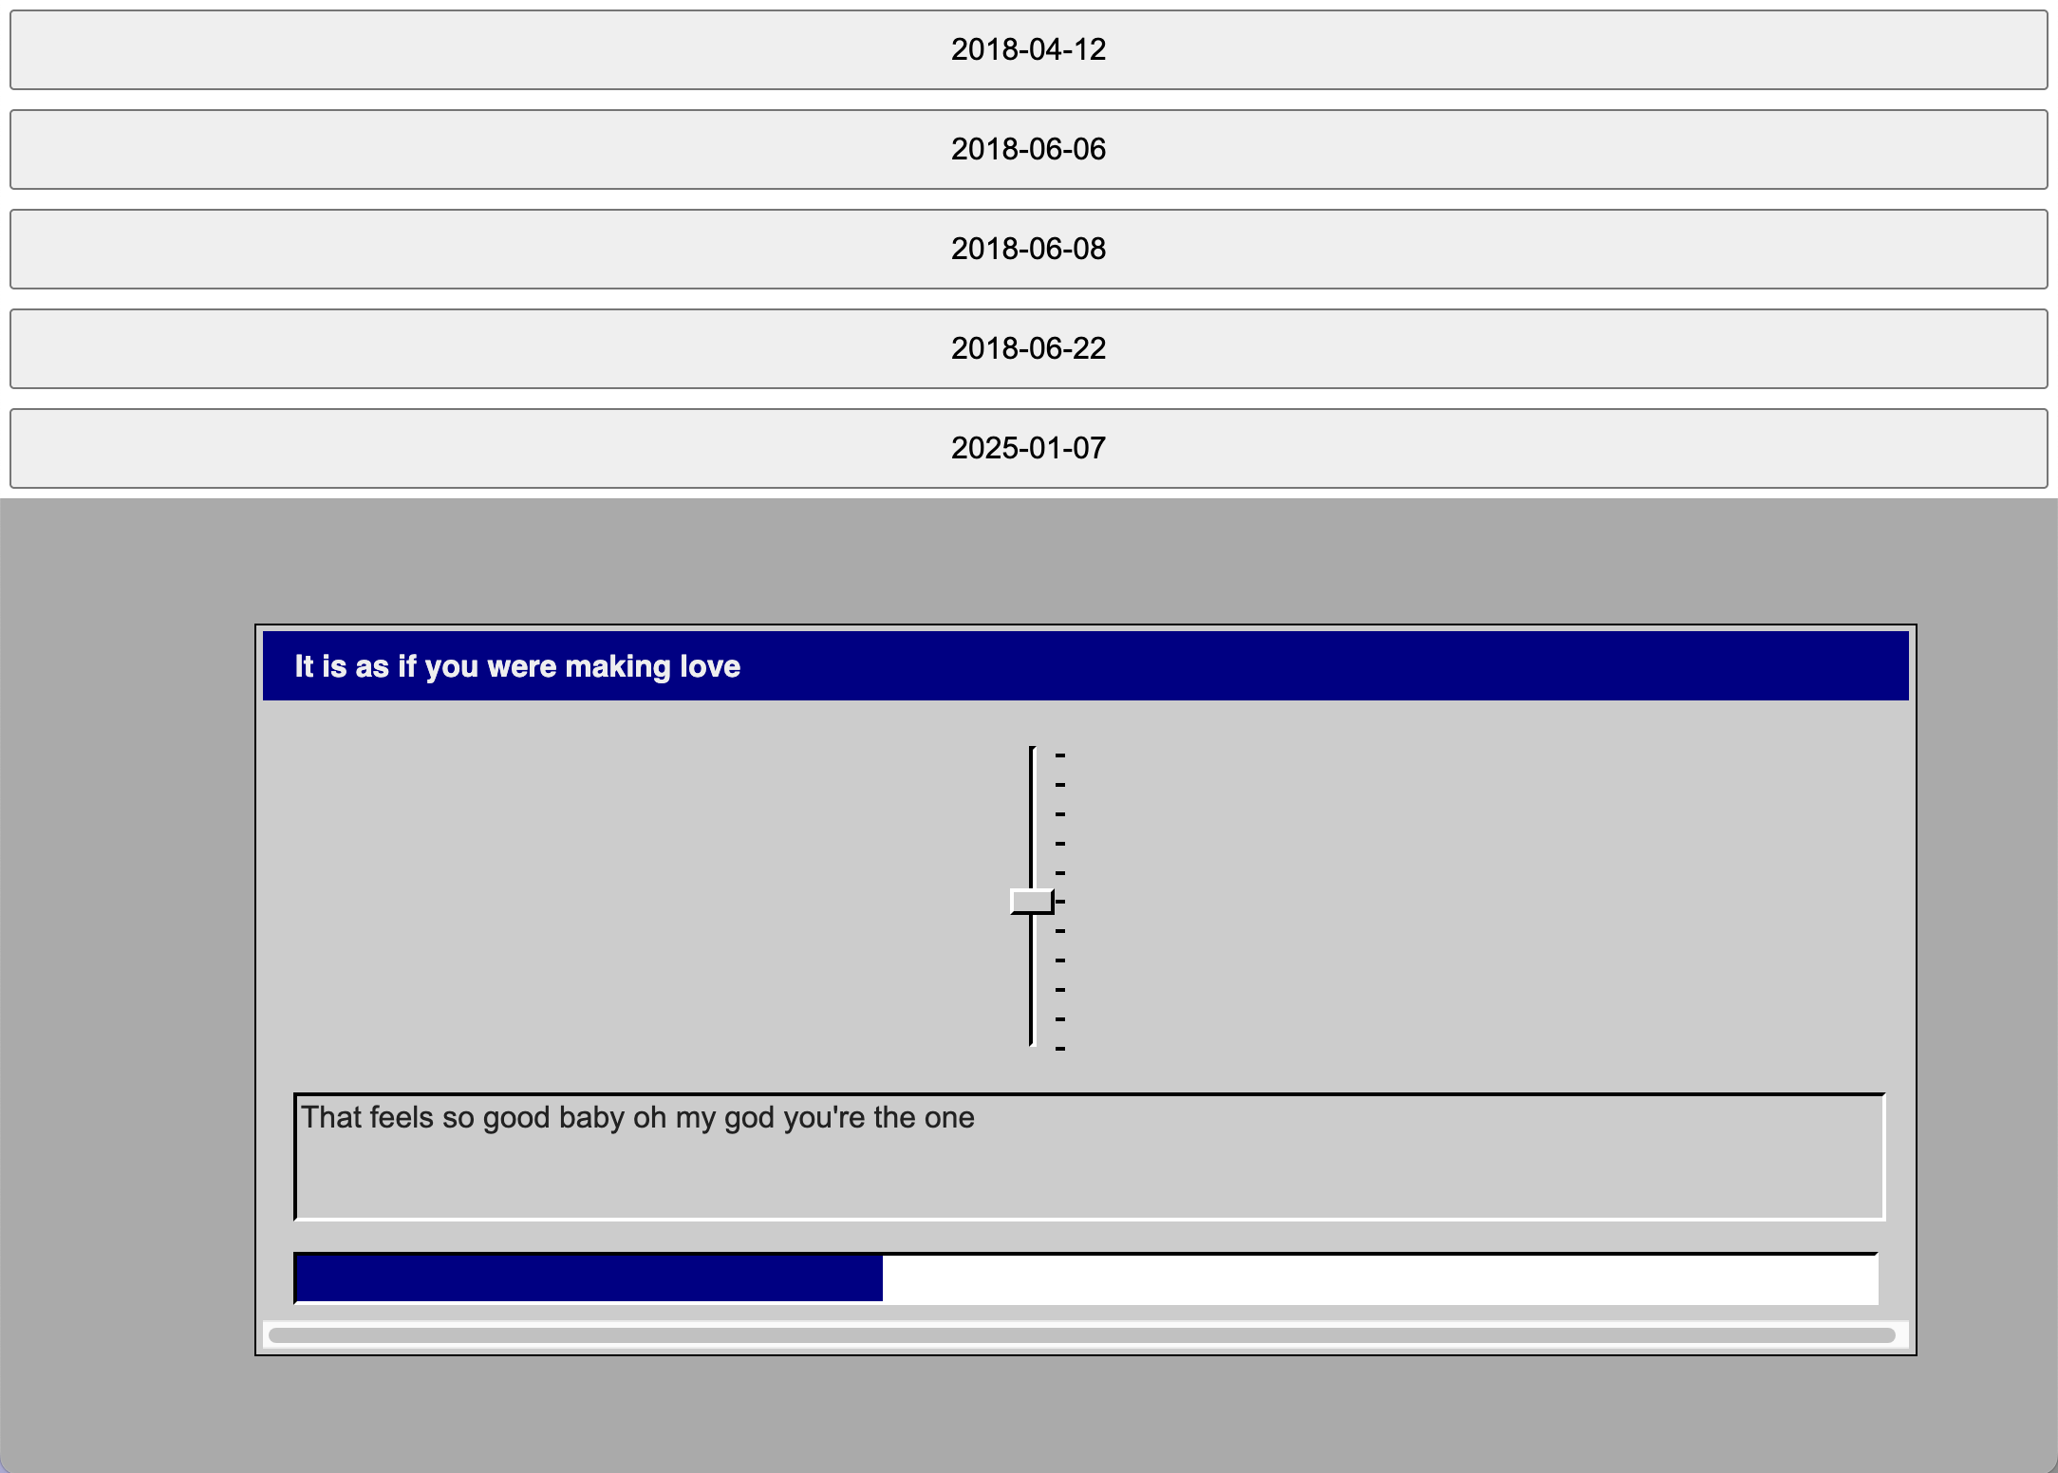

## 2025-04-25 Csongor: ⬇️ or ➡️

Dear Haniyeh,  
this already looks and works so much more amazing, thaaanks!

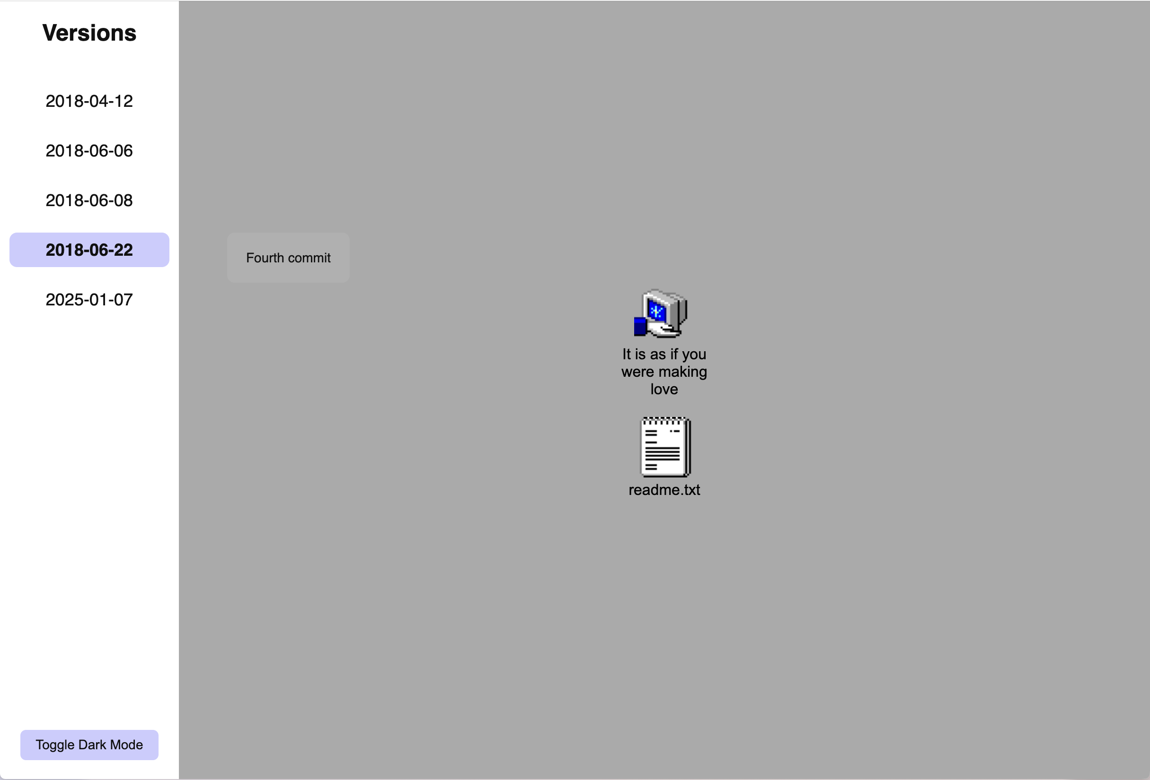

The main question I have is: *vertical* or *horizontal*?  
Maybe thats on the exhibition team to answer, but my feeling is *horizontal*, as we want to (?) put a timeline-visualisation on top of the monitors, do we?

Just a small additional ideas / brainstorming:

* I would suggest to differentiate into different files for different things, to make editing (by different people) easier
  + one file for the colors
  + one file for game related info (game title, very maybe horizontal or vertical, etc.)
  + one file for versions related info (folder, name, date, description)
* not sure about the dark mode, as… we want to have different colors for each game
* the transitions between the version are amazing, so much better!
* so cool that the selected version stays visible!
* not sure, but sometimes we might want to have a wrapper for the versions, like for 2018-06-06, as this is not meant to be soooooo wide I suppose

Such things!  
But amazing, let’s discuss and brainstorm later together!

## 2025-04-26 Csongor: Yesss!

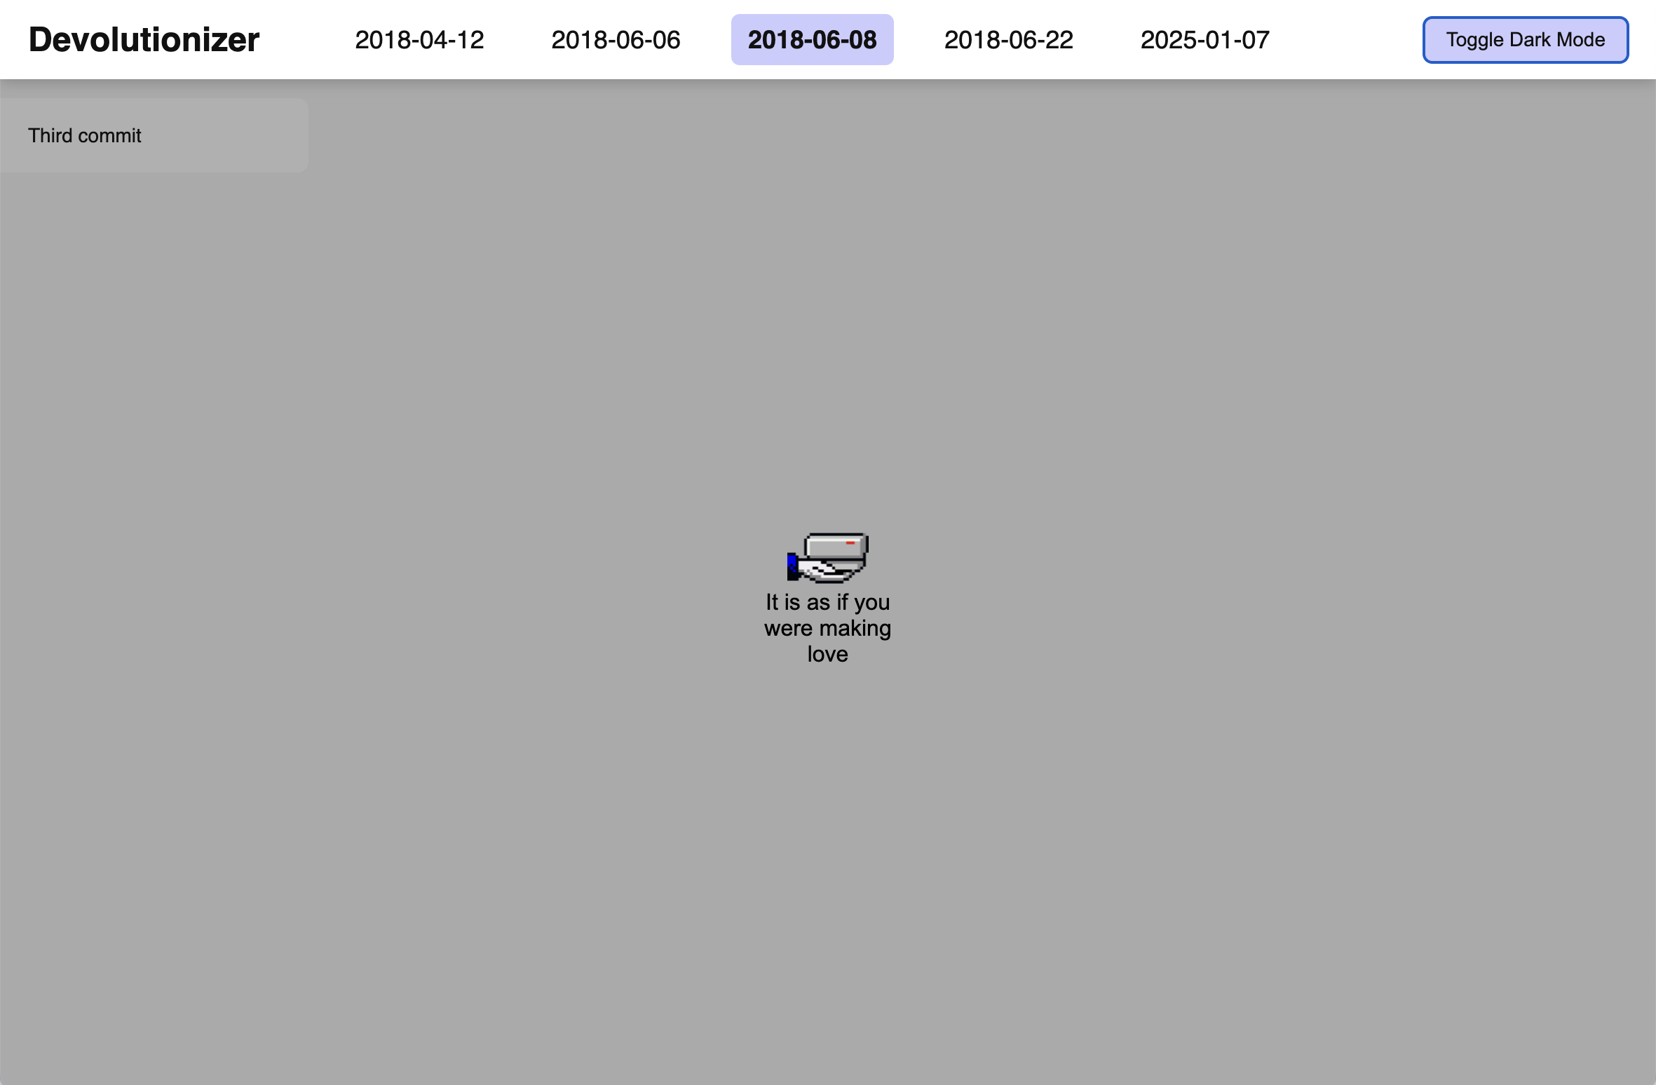

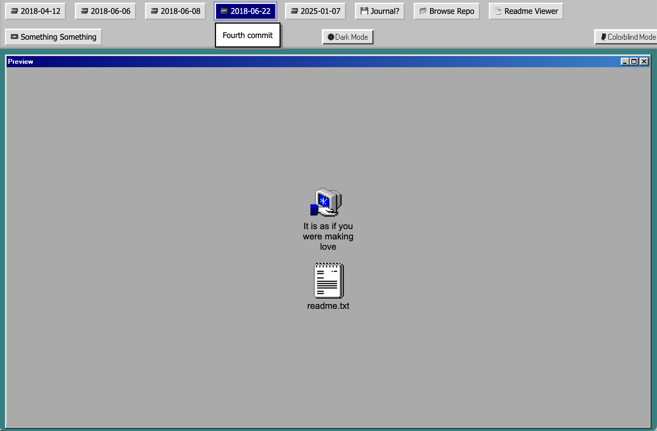

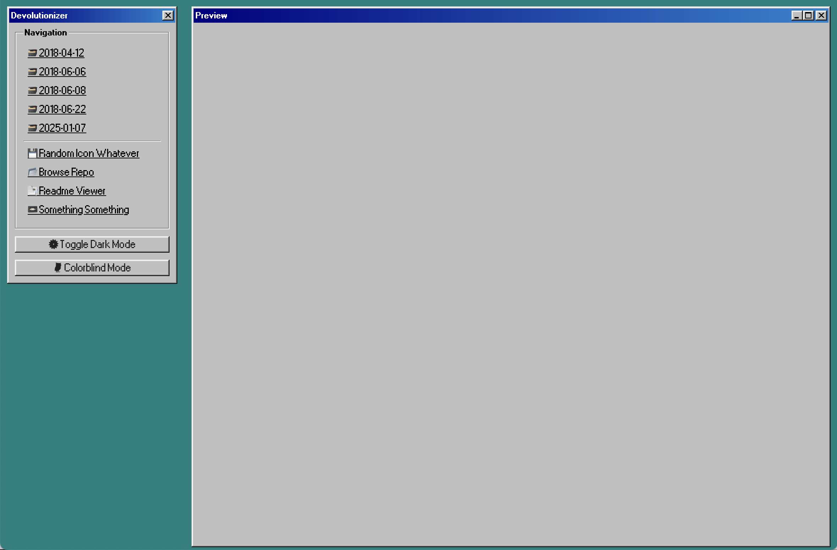

Dear Haniyeh,  
this is just so cool! Just so happy to see them, it works so well, makes fun to check, to compare.  
Not sure what the others will say, but here some faaast impressions from my side:

* retro is… yeah! but I also feel:
  + either the design needs to go together with each of the names (Work & Love are great with Win, but Text Adventure? maybe…)
  + or we need something more neutral, fitting the the general style
* for the additional stuff / links: I think if we focus on the exhibition… we don’t really need them, as the visitors should look at the booklets, NOT at the original repositories
  + maybe we can make an update after the exhibition?

See you!

Feature request: can you always show the first version after start?

# commits.md

**Wed, 08 Jan 2025 14:46 - Csongor**  
I guess we need to start it somewhere…

**Wed, 08 Jan 2025 12:38 - Pippin**  
Dialogue: Pippin

**Thu, 09 Jan 2025 16:28 - Csongor**  
Running…

**Fri, 10 Jan 2025 10:00 - Pippin**  
Dialogue: Pippin replies too soon

**Fri, 10 Jan 2025 16:57 - Csongor**  
Sorting thoughts.

**Fri, 10 Jan 2025 16:59 - Csongor**  
Is this allowed?

**Fri, 10 Jan 2025 17:19 - Csongor**  
Parallel thinking.

**Fri, 10 Jan 2025 17:32 - Csongor**  
Why is this bothering me so much?

**Mon, 13 Jan 2025 14:45 - Pippin**  
Pippin: Great minds

**Tue, 21 Jan 2025 07:20 - Csongor**  
Serial?

**Fri, 24 Jan 2025 22:11 - Csongor**  
Devolutionizer?

**Sat, 01 Feb 2025 16:52 - Csongor**  
Two in one.

**Thu, 13 Feb 2025 16:58 - Pippin**  
Pippin: ≡ƒÿ¼

**Tue, 18 Feb 2025 16:33 - Pippin**  
Pippin: ≡ƒÆ¬

**Mon, 03 Mar 2025 12:27 - Csongor**  
Open World.

**Wed, 05 Mar 2025 23:23 - Csongor**  
Explosion!

**Thu, 06 Mar 2025 13:23 - Pippin**  
Pippin: ≡ƒñí

**Mon, 10 Mar 2025 14:32 - Csongor**  
Letter to Jesse regarding style & printing & booklets.

**Sun, 16 Mar 2025 20:09 - Csongor**  
ΓÿÇ∩╕Å

**Mon, 17 Mar 2025 14:30 - Csongor**  
Adding booklet-test with Quarto, incl. Journal. Tutorial is missing.

**Mon, 17 Mar 2025 14:43 - Csongor**  
Added quick Quarto Tutorial.

**Mon, 17 Mar 2025 15:52 - Csongor**  
Added git-export info, so that we have thee style for all booklets.

**Mon, 17 Mar 2025 19:40 - Agustina**  
added commit_log.qmd

**Mon, 17 Mar 2025 19:55 - Csongor**  
Merged commit messages into the right chapter. Looks better. Still not finished.

**Thu, 20 Mar 2025 17:36 - Csongor**  
Testing style of commit messages (booklet).

**Thu, 20 Mar 2025 17:37 - Csongor**  
Adding images to Journal (Phone).

**Thu, 20 Mar 2025 17:48 - Csongor**  
Messing around with gitignore for Quarto… not exactly sure. We’ll see.

**Thu, 20 Mar 2025 18:02 - Csongor**  
Using a more proper reference for this project.

**Thu, 20 Mar 2025 18:02 - Csongor**  
Deleting not needed Quarto cover image.

**Thu, 20 Mar 2025 18:05 - Csongor**  
Added Quarto project for “Work”.

Happy to see that you can have several Quarto projects in thee repository…

**Thu, 20 Mar 2025 18:09 - Csongor**  
Added Quarto project for “Love”.

**Thu, 20 Mar 2025 18:12 - Csongor**  
Added Quarto project for “Blank”.

**Thu, 20 Mar 2025 18:14 - Csongor**  
Added Quarto project for “Growing Stuff” (very much a working title).

**Sat, 22 Mar 2025 10:54 - Csongor**  
Added first exhibition overview.

**Sat, 22 Mar 2025 14:19 - Csongor**  
Tiny clarifications, as I need to send this to Jesse.

**Sat, 22 Mar 2025 16:03 - Csongor**  
Phone booklet: added commit overview.

* more details? better design for sure!

**Sat, 22 Mar 2025 16:04 - Csongor**  
Added original Why.md.

* merging it into Journal?

**Sat, 22 Mar 2025 16:52 - Csongor**  
Added some original todo files. Updated booklet todos (inspired by?).

**Sat, 22 Mar 2025 18:00 - Csongor**  
Phone booklet: added original press release.

**Mon, 24 Mar 2025 16:42 - Agustina**  
Added instructions for Git log extract

**Thu, 27 Mar 2025 16:03 - Agustina**  
added commit log for work booklet

**Thu, 27 Mar 2025 16:06 - Agustina**  
added commit log booklet love

**Fri, 28 Mar 2025 11:41 - Agustina**  
Updated commit_log.qmd work

**Fri, 28 Mar 2025 11:47 - Agustina**  
Updated commit_log.qmd love

**Fri, 28 Mar 2025 11:56 - Agustina**  
Updated commit_log.qmd phone

**Fri, 28 Mar 2025 12:06 - Agustina**  
added commits over time .pngs

**Fri, 28 Mar 2025 12:24 - Agustina**  
added to-do.md of work and love

**Fri, 28 Mar 2025 12:51 - Csongor**  
Merged commit-logs into the booklet (Phone).

**Fri, 28 Mar 2025 14:12 - Csongor**  
Big update on Phone, solid structure, not finished graphs, not finished intro, etc.

**Fri, 28 Mar 2025 15:59 - Csongor**  
Love: Added Journal to booklet (incl. original file).

**Fri, 28 Mar 2025 16:07 - Csongor**  
Added manifesto & related work (Love); some general booklet settings.

**Fri, 28 Mar 2025 16:18 - Csongor**  
Love: added commits (formatting still TBD).

**Fri, 28 Mar 2025 17:07 - Csongor**  
Love booklet: added to-do (history missing).

**Fri, 28 Mar 2025 19:57 - Csongor**  
Work: finally, first version of the booklet, yeah. Far from finished.

**Fri, 28 Mar 2025 16:42 - Pippin**  
Dialogue/Onstage/Booklets: Pippin Strikes Back

**Sun, 30 Mar 2025 21:20 - Csongor**  
Added info to phone

* synchronizing the structures between booklets
* beginning of the booklets still not clear

**Sun, 30 Mar 2025 21:22 - Csongor**  
Added some first rough versions of the 3 main booklets (PDF & docx).

**Sun, 30 Mar 2025 22:49 - Csongor**  
Added booklet for Chess / Paperwork / Text Adventure.

* Not sure if having them all in one booklet is a gooooood idea. Maybe a separation would be good? But some of them would be really small…
* Finally, with knowing how Quarto works: much better (less chaotic) file structure!

**Sun, 30 Mar 2025 22:57 - Csongor**  
Update on the blank booklet (deleted Quarto project, added some ideas).

**Sun, 30 Mar 2025 23:05 - Csongor**  
Added direct links to the PDFs & docx-s to make life easier.

**Sun, 30 Mar 2025 23:07 - Csongor**  
Broken links, this time?

**Sun, 30 Mar 2025 23:09 - Csongor**  
This time?

**Sun, 30 Mar 2025 23:10 - Csongor**  
Whaaaaat?

**Mon, 31 Mar 2025 14:34 - Csongor**  
Typo.

**Mon, 31 Mar 2025 19:57 - Csongor**  
Lost an index.qmd file.

**Mon, 31 Mar 2025 19:58 - Csongor**  
Update regarding the workInProgress booklet. Brainstorming.

**Mon, 31 Mar 2025 20:26 - Csongor**  
Tiny change to make PDF rendering work.

**Mon, 31 Mar 2025 21:38 - Csongor**  
More ideas on the blank booklet.

**Mon, 31 Mar 2025 21:40 - Csongor**  
The Stuff Booklets Are Made Of

**Tue, 01 Apr 2025 15:23 - Pippin**  
Pippin talks Booklets and Onstage

**Thu, 03 Apr 2025 18:34 - Csongor**  
Love!

**Fri, 04 Apr 2025 11:13 - Csongor**  
BIG restructuring of the booklet files, now that I have a better understanding how all this works.

Unfortunately still not finished, might be chaotic for a while.

**Fri, 04 Apr 2025 11:34 - Csongor**  
Deleting “work in progress” booklet, not needed anymore.

**Fri, 04 Apr 2025 12:35 - Csongor**  
Chess & Paperwork & Text Adventure booklets are all working now.

**Fri, 04 Apr 2025 12:51 - Agustina**  
added chess commit_log.qmd

**Fri, 04 Apr 2025 12:52 - Csongor**  
Added Quarto structure for Growing Stuff.

**Fri, 04 Apr 2025 12:54 - Agustina**  
added commit_log.qmd text adventure

**Fri, 04 Apr 2025 12:56 - Agustina**  
nevermind that was for paperwork oopsie

**Fri, 04 Apr 2025 12:58 - Agustina**  
added commit_log.qmg text adventure

**Fri, 04 Apr 2025 12:59 - Csongor**  
Added content folder for Love.

**Fri, 04 Apr 2025 13:08 - Agustina**  
created commits.qmd for chess

**Fri, 04 Apr 2025 13:38 - Agustina**  
added commit_log for meta

**Fri, 04 Apr 2025 14:24 - Agustina**  
updated commit_log for meta

**Fri, 04 Apr 2025 16:01 - Csongor**  
Love: reworked main structure; moved shared content to shared folder.

**Fri, 04 Apr 2025 16:39 - Csongor**  
Slowly getting a feeling for a possible intro for the booklets (trying first with Love).

**Fri, 04 Apr 2025 16:45 - Csongor**  
Some notes on Designer’s Notebook.

**Fri, 04 Apr 2025 17:40 - Csongor**  
Added some first content to meta booklet. Let’s see…

**Fri, 04 Apr 2025 19:41 - Csongor**  
More meta booklet update, added dialogue and commit messages.

This was more fun than expected. I mean, hey, I can write a booklet like this?

**Fri, 04 Apr 2025 19:51 - Csongor**  
Updated links to be able to find the PDFs faster.

**Fri, 04 Apr 2025 19:56 - Csongor**  
Externalized todos into an extra file (learning from Pippin I guess).

**Sat, 05 Apr 2025 13:53 - Csongor**  
Added rough structure for the versions.

**Sat, 05 Apr 2025 13:55 - Csongor**  
Added screenshot.

**Sat, 05 Apr 2025 14:29 - Csongor**  
Chess / Paperwork / Text Adventure: added commit messages; removed references.bib & timeline image.

**Tue, 08 Apr 2025 22:02 - Csongor**  
Jump!

**Tue, 08 Apr 2025 22:03 - Csongor**  
Some embarassing mistakes.

**Tue, 08 Apr 2025 18:02 - Pippin**  
Pippin: np!

**Fri, 11 Apr 2025 08:09 - Csongor**  
Added credits in a real meta-way. The most meta-credits of all times!

**Fri, 11 Apr 2025 17:51 - Agustina**  
Added displayable love versions

**Fri, 11 Apr 2025 18:06 - Csongor**  
Added file-structure to Love.

**Fri, 11 Apr 2025 18:28 - Agustina**  
Added displayable work versions

**Fri, 11 Apr 2025 18:49 - Rodrigo**  
file structure edit

**Fri, 11 Apr 2025 18:50 - Agustina**  
Added displayable phone versions

**Fri, 11 Apr 2025 19:02 - Agustina**  
Added displayable versions for chess, paperwork and text adventure

**Fri, 11 Apr 2025 20:57 - Csongor**  
Messing around with timeline visualisations; added license info.

**Fri, 11 Apr 2025 21:22 - Csongor**  
Missing a resolution.

**Sat, 12 Apr 2025 13:42 - Csongor**  
Added Miro boards to GrowingStuff booklet (experimental).

**Sun, 13 Apr 2025 10:30 - Csongor**  
Trying references as footnotes.

(Harvard, Cite Them Right 12th edition)

**Sun, 13 Apr 2025 22:59 - Csongor**  
Updated File Structure of Love.

**Sun, 13 Apr 2025 23:12 - Csongor**  
Restructured references; moved around imprint and license (Love).

**Sun, 13 Apr 2025 23:13 - Csongor**  
Messing around with preferences (previous commit might not work without these).

**Sun, 13 Apr 2025 23:20 - Csongor**  
Added new reference structure…

…to GrowingStuff and finished it for Love; added epub.

**Mon, 14 Apr 2025 01:23 - Csongor**  
Restucturing Love.

I like how this sounds… The whole first few pages are new now, much better (though still not fully finished).

**Mon, 14 Apr 2025 01:24 - Csongor**  
Added more versions of To Dos.

**Mon, 14 Apr 2025 01:24 - Csongor**  
Added rendered Love booklets.

**Mon, 14 Apr 2025 01:31 - Csongor**  
Update to the intro of GrowingStuff, still not finished.

**Mon, 14 Apr 2025 01:32 - Csongor**  
Deleted contact from phone (moved to imprint).

**Mon, 14 Apr 2025 12:35 - Rodrigo**  
added paperwork filestructure.qmd file

**Mon, 14 Apr 2025 12:49 - Rodrigo**  
added timeline design options

**Mon, 14 Apr 2025 10:47 - Pippin**  
Onstage: Pippin YES ANDS

**Mon, 14 Apr 2025 17:54 - Rodrigo**  
edited structure file

**Mon, 14 Apr 2025 20:10 - Csongor**  
Love-Test.

**Mon, 14 Apr 2025 20:22 - Csongor**  
Added additional version.

This already feels really great…

**Tue, 15 Apr 2025 08:56 - Rodrigo**  
added chess filestructure.qmd file

**Thu, 17 Apr 2025 07:53 - Rodrigo**  
added text adventure filestructure.qmd file

**Thu, 17 Apr 2025 14:24 - Rodrigo**  
added work filestructure.qmd file and new timeline design file

**Thu, 17 Apr 2025 16:52 - Rodrigo**  
finished all date entries for the work filestructure .qmd file

**Sat, 19 Apr 2025 10:45 - Csongor**  
Added content folder for Phone & Work.

**Sat, 19 Apr 2025 10:46 - Csongor**  
Added unified Commit visualisations to all booklets.

Not perfect, but good enough and all thee. Already something.

**Sat, 19 Apr 2025 10:50 - Csongor**  
Finished (?) restructuring the booklet folders.

**Sat, 19 Apr 2025 11:12 - Csongor**  
First designed draft! Love!

**Sat, 19 Apr 2025 12:33 - Csongor**  
Reworked intro of Love, shorter, more self-contained.

**Sat, 19 Apr 2025 13:22 - Csongor**  
Updated yaml-files for some Quarto booklets; Work & Phone are working again.

**Sat, 19 Apr 2025 13:37 - Rodrigo**  
added phone filestructure.qmd file

**Sat, 19 Apr 2025 13:46 - Agustina**  
deleted sentence

**Sat, 19 Apr 2025 14:45 - Agustina**  
updated play online link footnote in love press readme.qmd

**Sat, 19 Apr 2025 15:02 - Csongor**  
Fast in-between commit…

**Sat, 19 Apr 2025 15:14 - Rodrigo**  
added meta filestructure .qmd file

**Sat, 19 Apr 2025 15:59 - Csongor**  
Last touches on Love (todos are still a todo, haha).

**Sat, 19 Apr 2025 15:59 - Csongor**  
New rendered versions of Love (for Jesse).

**Sat, 19 Apr 2025 16:11 - Csongor**  
As always: one more change (Love - Imprint).

**Sat, 19 Apr 2025 16:12 - Csongor**  
Restructuring Growing Stuff (far from finished).

**Sat, 19 Apr 2025 22:30 - Agustina**  
reworked work’s press kit info to align to love format

**Sat, 19 Apr 2025 22:31 - Agustina**  
corrected some formatting and links in work commits

**Sat, 19 Apr 2025 23:09 - Csongor**  
Eastern, I guess.

**Sat, 19 Apr 2025 23:24 - Agustina**  
reworked phone’s press kit info to align to love format

**Sat, 19 Apr 2025 23:34 - Agustina**  
removed license section and added footnote on paperwork info.qmd

**Sat, 19 Apr 2025 23:40 - Agustina**  
removed license section and added footnote on text adventure info.qmd

**Sat, 19 Apr 2025 23:44 - Csongor**  
Message to Jesse.

**Sun, 20 Apr 2025 12:54 - Rodrigo**  
finished editing meta filestructure .qmd file

**Sun, 20 Apr 2025 19:55 - Rodrigo**  
shortened love to-do.qmd file

**Mon, 21 Apr 2025 09:16 - Rodrigo**  
shortened work to-do.qmd file

**Mon, 21 Apr 2025 09:30 - Rodrigo**  
additional work to-do.qmd edit

**Mon, 21 Apr 2025 10:15 - Rodrigo**  
shortened phone to-do.qmd file

**Mon, 21 Apr 2025 13:33 - Levent**  
added the quotes

**Mon, 21 Apr 2025 14:03 - Levent**  
Update readme.md

**Mon, 21 Apr 2025 14:08 - Levent**  
Update readme.md

**Mon, 21 Apr 2025 14:13 - Levent**  
Update readme.md

hope this one looks good

**Mon, 21 Apr 2025 14:14 - Csongor**  
Love: shortened todos even more.

**Mon, 21 Apr 2025 14:14 - Levent**  
Update readme.md

**Mon, 21 Apr 2025 14:17 - Csongor**  
Formatting.

**Mon, 21 Apr 2025 14:38 - Levent**  
Update readme.md

**Mon, 21 Apr 2025 14:45 - Csongor**  
Some restructuring of quotes.

**Mon, 21 Apr 2025 15:07 - Csongor**  
Adding some new sections.

**Mon, 21 Apr 2025 15:07 - Agustina**  
modified qmd titles for work, love and text adventure files

**Mon, 21 Apr 2025 15:09 - Csongor**  
Added sections to Chess.

**Mon, 21 Apr 2025 15:10 - Agustina**  
modified more qmd titles for text adventure files

**Mon, 21 Apr 2025 15:13 - Agustina**  
modified qmd titles for all paperwork files

**Mon, 21 Apr 2025 15:19 - Levent**  
Added Chess Quotes

**Mon, 21 Apr 2025 15:20 - Csongor**  
Small restructuring of Love.

**Mon, 21 Apr 2025 15:23 - Agustina**  
modified qmd titles for more work files

**Mon, 21 Apr 2025 15:25 - Rodrigo**  
edited work to-do.qmd file

**Mon, 21 Apr 2025 15:45 - Csongor**  
Selected some quotes (together with Levent, Agustina, Rodri).

**Mon, 21 Apr 2025 16:48 - Rodrigo**  
shortened the phone to-do.qmd file even more

**Mon, 21 Apr 2025 17:21 - Csongor**  
Edited file-structure and to-dos (Phone, Work, Chess).

**Mon, 21 Apr 2025 17:23 - Csongor**  
Added imprint to Work.

**Mon, 21 Apr 2025 17:28 - Csongor**  
TOC update for Work, now…

**Mon, 21 Apr 2025 17:55 - Agustina**  
added imprint and index for chess

**Mon, 21 Apr 2025 17:59 - Rodrigo**  
added imprint file for phone booklet

**Tue, 22 Apr 2025 00:01 - Csongor**  
Steamlining all (besides Growing Stuff) booklets.

I suppose I have forgotten some things, typos, etc.

**Tue, 22 Apr 2025 00:11 - Csongor**  
Rendered all booklets (besides Growing Stuff).

**Tue, 22 Apr 2025 00:36 - Csongor**  
Reversed journal entries in Work.

**Tue, 22 Apr 2025 00:44 - Csongor**  
Added Social Media images.

**Tue, 22 Apr 2025 00:45 - Csongor**  
Content-freeze & production team.

**Tue, 22 Apr 2025 00:47 - Csongor**  
Updated booklet to-dos…

Learning from Pippin, doing this in a file makes a lot of sense as an in-between thing between a task-board and agile and sticky-notes and chaos.

**Tue, 22 Apr 2025 00:58 - Csongor**  
Updated conversation with Jesse.

**Tue, 22 Apr 2025 01:03 - Csongor**  
Tiny update of the message to Jesse.

**Tue, 22 Apr 2025 01:04 - Csongor**  
Update on the blank booklet… still work in progress.

**Tue, 22 Apr 2025 06:23 - Haniyeh**  
Graphs Test

**Tue, 22 Apr 2025 11:13 - Csongor**  
Testing deployment…

**Tue, 22 Apr 2025 12:46 - Csongor**  
Added structure for Credits.

**Tue, 22 Apr 2025 12:49 - Diana**  
Added first iteration of credits.

**Tue, 22 Apr 2025 13:01 - Diana**  
Design test.

**Tue, 22 Apr 2025 13:14 - Diana**  
Testing HTML in formatting credits.

**Tue, 22 Apr 2025 13:24 - Diana**  
Reformatted details of exhibition in credits.

**Tue, 22 Apr 2025 13:26 - Diana**  
Testing new format for credits.

**Tue, 22 Apr 2025 14:10 - Csongor**  
Restructuring versions.

**Tue, 22 Apr 2025 12:01 - Pippin**  
Dialog: Pippin: Deer in the headlights

**Wed, 23 Apr 2025 11:33 - Pippin**  
Pippin added bios and headshot

**Wed, 23 Apr 2025 11:50 - Pippin**  
Pippin lit his headshot better

**Wed, 23 Apr 2025 18:41 - Csongor**  
Tiny re-formatting on Work (just the start).

**Wed, 23 Apr 2025 18:53 - Csongor**  
Added new content for Text Adventure.

This feels particularly funny, chasing Pippin, who is faster?

**Wed, 23 Apr 2025 18:57 - Csongor**  
Tiny change to indicate that Pippin is still working on Text Adventure.

**Wed, 23 Apr 2025 19:02 - Levent**  
Formatted work - journal.md Titles

**Wed, 23 Apr 2025 21:02 - Levent**  
Formatted work journal.qmd Titles

**Wed, 23 Apr 2025 21:59 - Marta**  
Created a visual elements list for the exhibition

**Wed, 23 Apr 2025 22:57 - Taisia**  
Added link to my instagram in the credits

**Wed, 23 Apr 2025 23:00 - Taisia**  
Put the link to insta right after my name in credits

**Thu, 24 Apr 2025 11:34 - Csongor**  
Linking to visual elements.

**Thu, 24 Apr 2025 11:49 - Csongor**  
Acknowledging that Text Adventure is ongoing…

**Thu, 24 Apr 2025 11:50 - Csongor**  
New renderings for Work & Text Adventure.

**Thu, 24 Apr 2025 11:51 - Csongor**  
Added more structured folder for Dessauer Press / Jesse.

**Thu, 24 Apr 2025 12:03 - Csongor**  
Messing around with the structure of the versions…

Unfortunately still not satisfied, but at least its slightly better?

**Thu, 24 Apr 2025 12:26 - Csongor**  
Commenting Phone draft for Jesse.

**Thu, 24 Apr 2025 12:45 - Csongor**  
Moved Rodri-s timeline visualisations to an extra folder.

**Thu, 24 Apr 2025 12:46 - Csongor**  
Added more timeline ideas.

**Thu, 24 Apr 2025 12:48 - Csongor**  
Added more screenshots/images to show the process…

This feels strange, again. Doing things because I know I want to have them in Growing Stuff. How much is this “faking it”?

**Thu, 24 Apr 2025 16:23 - Csongor**  
First rough version of the short descriptions for the Amaze schedule.

**Thu, 24 Apr 2025 16:28 - Csongor**  
Typos; mentioning Marina Abramovi─ç, should we?

**Thu, 24 Apr 2025 16:31 - Csongor**  
Deleted links, as they are not working in code-blocks in md-files (makes sense).

**Thu, 24 Apr 2025 17:14 - Csongor**  
Added new commit messages to Growing Stuff.

**Fri, 25 Apr 2025 11:22 - Haniyeh**  
Navbar position

vertical- left corner

**Fri, 25 Apr 2025 11:24 - Haniyeh**  
Dark Mode Toggle

**Fri, 25 Apr 2025 11:40 - Haniyeh**  
Update index.html

**Fri, 25 Apr 2025 11:43 - Haniyeh**  
Version Description

**Fri, 25 Apr 2025 11:49 - Haniyeh**  
no more iframe blink

**Fri, 25 Apr 2025 12:00 - Haniyeh**  
Update index.html

**Fri, 25 Apr 2025 13:42 - Levent**  
Edited the names in booklet/growstuff/commits.qmd

**Fri, 25 Apr 2025 14:00 - Rodrigo**  
added 1 more entry to the meta filestructure.qmd file

**Fri, 25 Apr 2025 15:30 - Csongor**  
Notes on the Devolutionizer/Player (short: amaaaazing!).

**Fri, 25 Apr 2025 15:31 - Csongor**  
Tiny in-between changes in Growing Stuff.

**Fri, 25 Apr 2025 15:32 - Csongor**  
Added an additional early timeline ideation image.

**Fri, 25 Apr 2025 15:32 - Csongor**  
Added timeline to the front page.

**Fri, 25 Apr 2025 15:37 - Csongor**  
Added some history…

**Fri, 25 Apr 2025 15:48 - Csongor**  
Aaaah, added some arrows. Thats it. Shortest commit?

**Fri, 25 Apr 2025 15:48 - Taisia**  
Created emojis folder

**Fri, 25 Apr 2025 15:57 - Taisia**  
Created correct “Emojis” folder and added font files

**Fri, 25 Apr 2025 17:42:31 - Agustina**  
updated commits.qmd for growingstuff booklet

**Fri, 25 Apr 2025 20:24:54 - Csongor**  
Tiny update on the description of TDIP.

**Fri, 25 Apr 2025 20:36:29 - Csongor**  
Other on-stage update. Still, far from finished.

**Fri, 25 Apr 2025 20:37:42 - Csongor**  
New title (for the tour).

**Fri, 25 Apr 2025 21:42:52 - Csongor**  
Picked emojis for each of the versions.

# File Structure

## 2025-01-08

🌱 It is as if you were growing stuff/  
└── 📁 process/  
 └── dialogue.md

## 2025-03-05

🌱 It is as if you were growing stuff/  
├── 📁 booklets/  
 ├── 📁 00_growingstuff/  
 ├── 📁 01_work/  
 ├── 📁 02_love/  
 ├── 📁 03_chessPaperworkAdventure/  
 ├── 📁 04_phone/  
 ├── 📁 05_workInProgress/  
 ├── 📁 06_blank/  
 └── booklets.md  
├── 📁 onstage/  
├── 📁 process/  
 ├── 📁 screenshots/  
 ├── booklets.md  
 ├── dialogue.md  
 └── onstage.md  
├── .gitignore  
└── readme.md

## 2025-04-25

🌱 It is as if you were growing stuff/  
├── 📁 .github/  
├── 📁 booklets/  
 ├── 📁 00_blank/  
 ├── 📁 00_growingstuff/  
 ├── 📁 2016_chess/  
 ├── 📁 2017_work/  
 ├── 📁 2018_love/  
 ├── 📁 2022_paperwork/  
 ├── 📁 2024_textadventure/  
 ├── 📁 2025_phone/  
 ├── 📁 dessauerPress/  
 ├── 📁 sharedContent/  
 ├── readme.md  
 └── todo.md  
├── 📁 exhibition/  
├── 📁 onstage/  
├── 📁 process/  
├── 📁 timeline/  
├── 📁 versions/  
├── .gitignore  
├── credits.md  
└── readme.md

# Imprint

It is as if you were growing stuff

See: Love.

1. [github.com/csongorb/growingstuff](https://github.com/csongorb/growingstuff)
2. [github.com/csongorb/growingstuff/blob/main/credits.md](https://github.com/csongorb/growingstuff/blob/main/credits.md)
3. [speculativeplay.com](http://www.speculativeplay.com/)
4. [gamesasresearch.com](https://www.gamesasresearch.com)
5. Khaled, R., Lessard, J., and Barr, P. (2018) ’Documenting trajectories in design space: A methodology for applied game design research‘, in Proceedings of Foundations of Digital Games (FDG) 2018.
6. See Chapter 1
7. Khaled, R., Lessard, J., and Barr, P. (2018) ’Documenting trajectories in design space: A methodology for applied game design research‘, in Proceedings of Foundations of Digital Games (FDG) 2018. & Khaled, R. and Barr, P. (2023) ’A method for design materialization: Accountable game design research‘. Digital Games Research Association (DiGRA) Conference 2023. Seville, Spain. 19-23 June 2023.
8. Barr, P. (2023) The stuff games are made of. The MIT Press (p. 6-7).
9. [devolution.online](https://devolution.online/)
10. [github.com/pippinbarr/v-r-5/blob/main/process/journal.md](https://github.com/pippinbarr/v-r-5/blob/main/process/journal.md)
11. Barr, P. (2023) The stuff games are made of. The MIT Press (p. 5).
12. Barr, P. (2023) The stuff games are made of. The MIT Press (p. 6).
13. Pulp. (1995) ‘Common People’, Different Class. Island Records. [youtube.com/watch?v=lkpLbEM06qE](https://www.youtube.com/watch?v=lkpLbEM06qE)
14. [github.com/pippinbarr/v-r-5/blob/main/process/journal.md](https://github.com/pippinbarr/v-r-5/blob/main/process/journal.md)
15. [github.com/pippinbarr/it-is-as-if-you-were-on-your-phone/commits/main](https://github.com/pippinbarr/it-is-as-if-you-were-on-your-phone/commits/main/)
16. [github.com/pippinbarr/it-is-as-if-you-were-on-your-phone/blob/main/process/journal.md](https://github.com/pippinbarr/it-is-as-if-you-were-on-your-phone/blob/main/process/journal.md)
17. [github.com/pippinbarr/it-is-as-if-you-were-on-your-phone/blob/main/process/journal.md#i-ooped-in-the-code-pool-i-wanna-be-an-fsm-2025-01-28](https://github.com/pippinbarr/it-is-as-if-you-were-on-your-phone/blob/main/process/journal.md#i-ooped-in-the-code-pool-i-wanna-be-an-fsm-2025-01-28)
18. [stonetronix.com/gdc-2010](https://www.stonetronix.com/gdc-2010/)
19. [gdcvault.com/play/1012356/One-Page](https://gdcvault.com/play/1012356/One-Page)
20. [instagram.com/pippinbarr](https://www.instagram.com/pippinbarr/)
21. [github.com/csongorb/devolutionizer](https://github.com/csongorb/devolutionizer)
22. The Strokes. (2001) ‘Take It or Leave It’, Is This It. Rough Trade Records. [youtube.com/watch?v=C0qls7b5oAY](https://www.youtube.com/watch?v=C0qls7b5oAY)